A SQL is a language used to interact with Relational Database Management System (RDBMS). RDBMS is basically just a software application which we can use to create and manage different databases.

And so, we're going to talk about all of this stuff in this course. We’re going to start off with the basics. So, we'll just look at what is a database.

We’ll talk about the different types of databases. We'll talk about what SQL is and what it actually means and how you can use it to create databases.

And then we're going to go ahead and we're going to install something called a relational database management system. Which like I said, is just software that we can use to manage a database. We're going to install a relational database management system called MySQL.

And MySQL is one of the most popular database management systems for beginners. And also, just in general. So, MySQL is a great first system to learn. And so, once we have that all install, then we'll start writing SQL. So, we can write out little SQL code, little queries in order to create databases and create database tables and, you know, input information, retrieve information. And then we're going to get into writing SQL queries.

And queries are used to query a database. So, we'll create a database. We’ll populate it with information. And I’ll show you guys how you can write these little SQL queries to get specific pieces of information.

So, we'll start off with the basics and we'll just learn all of the fundamentals. And then I’m going to show you some more advanced techniques to getting information out of a database. And finally, I’m going to show you guys how you can actually design database schemas. So, a database schema is basically just like all of the different tables and all the different relations that the database is going to store.

What is a database?

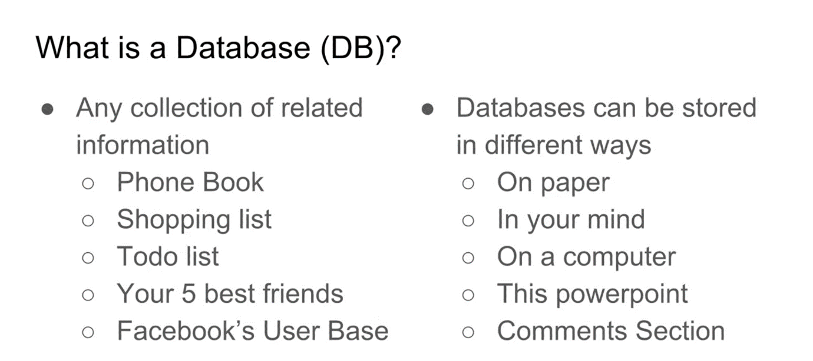

So, the phone book, right? This stores people’s phone numbers. Their names and their phone numbers. It’s a collection of related information. A to-do list – this stores a list of things that you want to do during the day, right? It’s related information. Your five best friends. That’s information. It’s information that you’re storing somewhere.

You have – you know, if I came up to you and asked you who your five best friends were, I’m sure you could list them off. That, in essence, is a database. It’s a collection of related information. And then Facebook’s userbase, right? So, all of the users that Facebook keeps track of and stores. That’s another example of a database. So, databases can be stored in different ways. So, you could store a database on paper. If I had a shopping list or a to-do list, I might just scribble that down on a piece of paper. You could store a database in your mind. So, your five best friends, for example. If I came up to you and I asked you, “List off your five best friends.” And you probably don’t have it written down somewhere. You don’t have an app on your phone that tells you who all your friends are, right? You just know that information in your mind naturally. And so, that’s another way that you can store a database. You can just store the information in your mind. You can store information on a computer. And this is probably the most common use case is people will create a database and they’ll store all the information on their computer. This MS Word, the MS Word that you're looking at right now. This is an example of a database. It has related information on it. And I’m using it to teach this lesson. And then finally go to youtube comment section. So, if you go down to the comment section of a particular video, that’s a database, right? It’s a general database that’s storing comments for the video. So, that really, in essence, is everything you need to know about databases to get started. It’s a collection of related information that can be stored in different ways. So, now that we understand the very general definition.

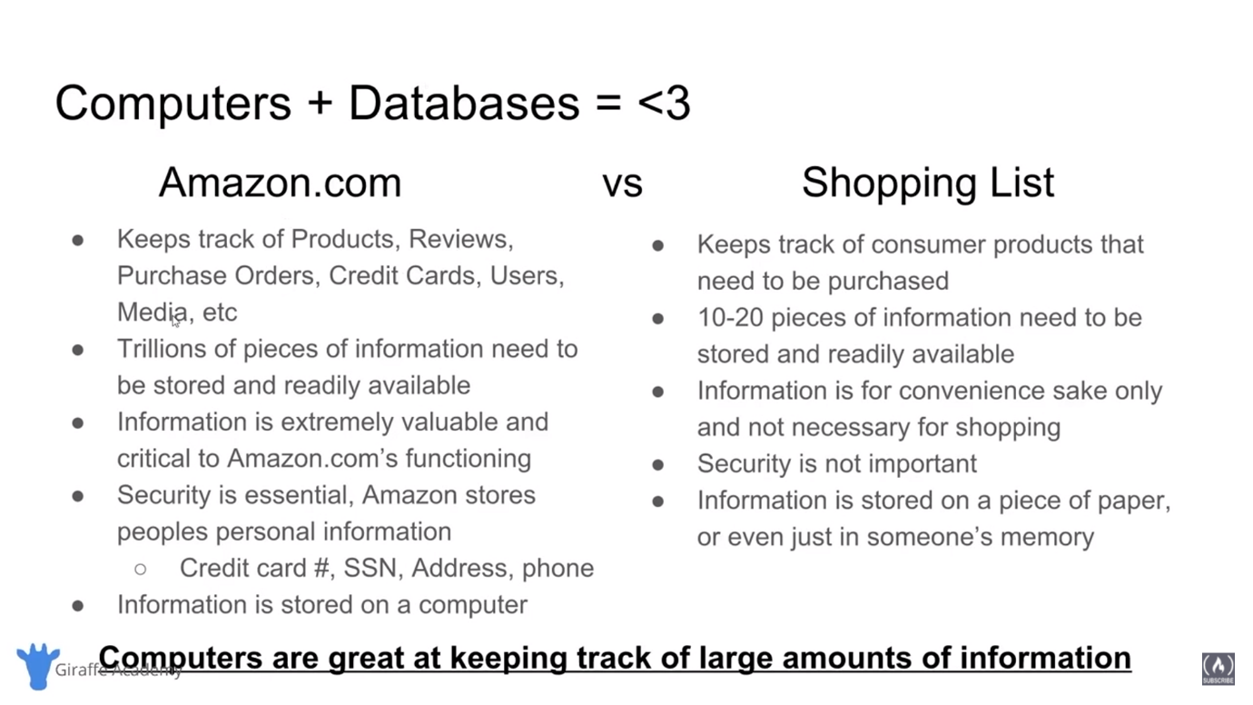

So, over here I have another slide. It’s Computers + Databases equals heart. Now, the point I’m trying to drive home with this slide is that storing a database, storing a collection of related information on a computer is extremely useful. And computers are actually great for storing databases. So, I have here two things. We have over here on the left, is Amazon vs on the Right Shopping List. So, these are two examples of situations where we have a database. We kind of talked about how a shopping list is a database. It’s a collection of related information, right? A collection of products that you want to buy from the store. Amazon.com is also a database. Amazon is storing all this product information, all this user information. They’re storing reviews on the products, the prices of the products. They’re storing all of this information. So, let’s take a look and we'll compare and contrast these two databases and we'll see why computers are the preferred medium for storing data. So, Amazon.com keeps track of products, reviews, purchase orders, credit cards, users, media, etc. So, Amazon is keeping track of so much information. Trillions of pieces of information need to be stored and readily available. Over here we have a shopping list. A shopping list keeps track of consumer products that need to be purchased, right? We're talking 10 to 20 pieces of information need to be stored and readily available. So, Amazon, we need to store trillions of pieces of information. With the shopping list, we need to store 10 or 20. Both of these are databases, but the one we have trillions of stuffs. The other one we have 10 to 20 things. And so, over here on Amazon, the information on Amazon is extremely valuable and it’s critical to Amazon.com’s functioning, right? So, the information that Amazon is storing its database is absolutely essential. And another thing is that security is essential, right? Amazon stores people’s personal information, like social security number or credit card, address, phone. Like that information needs to be locked down and secure. A shopping list on the other hand, the information is for convenience’s sake only, right? It’s not absolutely necessary for shopping. Like if you didn’t have a shopping list, you could still go to the store and, for the most part, you’d be able to find everything that you need. Also, with the shopping list, security is just not important at all, right? If you drop your shopping list on the ground – I mean if somebody else was to pick it up and look at it, it’s like not a big deal. It’s a shopping list. Finally, over here on Amazon, the information is stored on a computer. Whereas with the shopping list, the information is stored maybe on a piece of paper, or it could even just be stored in someone’s memory, right? So, maybe you just memorized your shopping list and that’s where you’re storing your shopping list database. So, what I’m trying to show you guys is that a database doesn’t just have to be on a computer and it doesn’t just have to be like in your memory or on a piece of paper, right? Databases are in all of these different environments. But here’s the thing, for an application like Amazon, storing information on something like a computer makes it really easy to store trillions of pieces of information. And really easy to secure the data and make sure that security is taken care of. And it also makes it really easy to back up that information and duplicate that information and store that information on different computers. So, the main point of this slide is that computers are great at keeping track of large amounts of information.

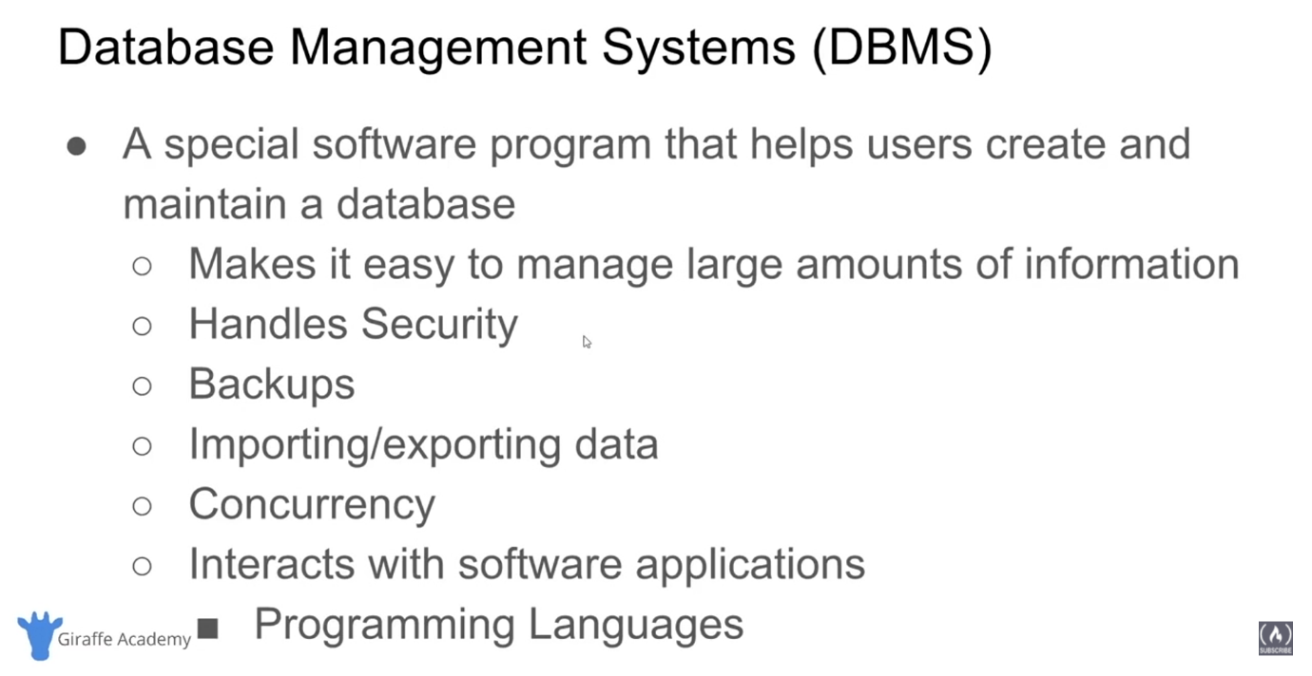

And so, going forward, we're going to be talking about how can we create databases on the computers because computers are so good at storing that information. So, let’s talk about how we can go about creating databases on a computer. Now, a database could be as simple as like a text file where you store information. Or it could be like an Excel file, right? Microsoft Excel file. But generally, if you’re going to be using a database with an application or you’re going to be using a database to store huge amounts of information, a lot of times what people will do is they’ll use special software which is designed to help you create and maintain the database. This is called database management systems. So, a database management system is a special software program that helps users create and maintain a database on a computer. So, it makes it really easy for us to manage large amounts of information. So, if you’re a company like Amazon and you have trillions of pieces of information that you need to keep track of, well, the database management system can make it pretty easy for you to store trillions of pieces of information, right? It’s not like all that information is just in like some single text file. The database management system will make it really easy for you to store that. Database management systems can also handle security. So, they can make it so only certain people with the usernames and passwords can access the data. It’ll also help you to backup your data and import and export data from other sources. So, if you have a bunch of information and you want to back it up, a database management system can help you do that. Database management systems can also interact with software applications. So, you know, Amazon.com is a website. And it’s interacting with the Amazon database which is stored mostly likely using a database management system. So, you could write a program that could interact with the database management system.

All right, so let’s take a look at this quick little diagram that I have here.

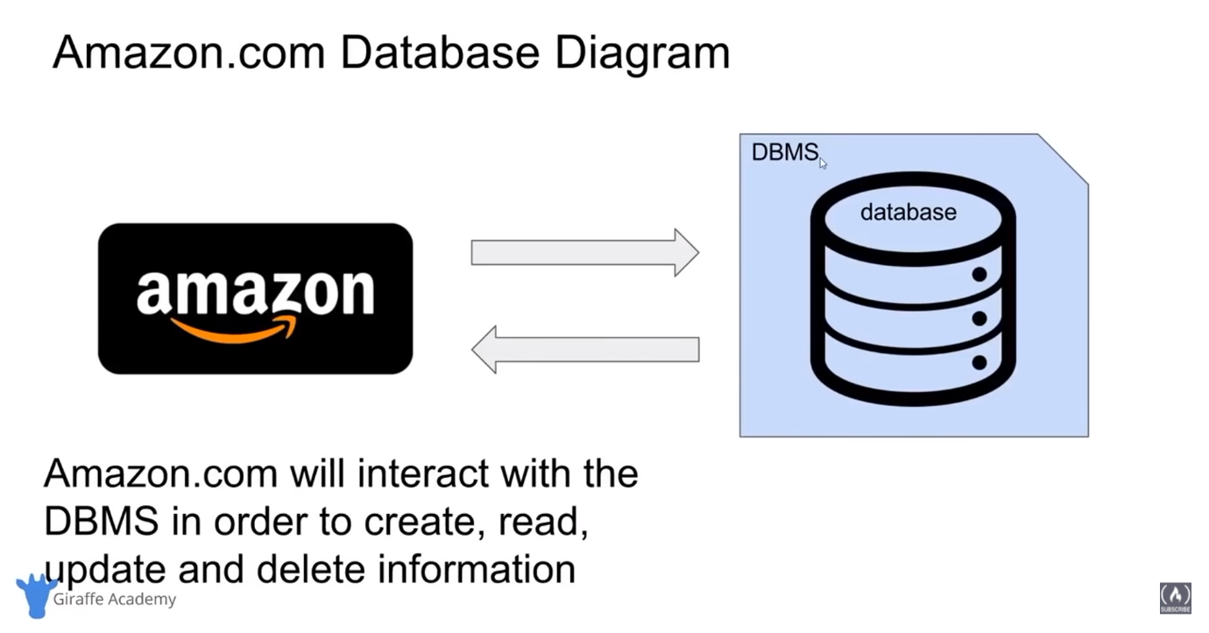

So, we have Amazon over here. And this would be like Amazon.com. And Amazon is communicating with a database management system. And I don’t work for Amazon so I’m not 100% sure exactly how they're doing this. But for the most part, this is the general use case. So, we have our database management system which is this little box here. And the database management system is creating and storing and keeping track of a database. So, the database management system isn’t the actual database. The database management system is the software application that is creating, maintaining, updating, deleting information from the actual database. So, Amazon.com will interact with the database management system in order to create, read, update, and delete information. So, Amazon isn’t creating or reading or updating this information directly. Amazon is telling the database management system to do that for it. And by going through the database management system, we can be sure that all the data is getting stored correctly and there’s going to be no problems with the data.

So, let’s talk about C.R.U.D. And this is an acronym that you’re going to hear a lot. C-R-U-D. It stands for Create, Read, Update, and Delete. You’ll also hear people call this Create, Retrieve, Update, and Delete.

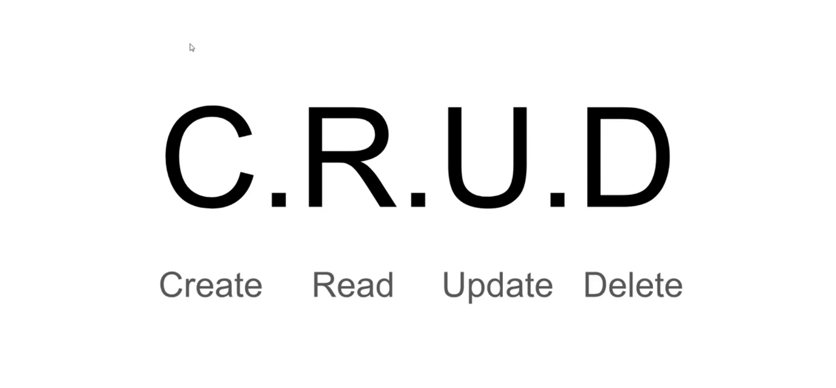

Now, CRUD represents the four main operations that we're going to be doing with the database. So, you’re going to be creating information in the database. So, creating new database entries. You’re going to be reading information from the database. So, you know, retrieving or getting the information that you already stored in there. You’re going to be updating the existing information. And you're going to be deleting the information that’s already in there. And these are the core four operations that we want the database management system to perform for us. So, any good database management system is going to be able to do all four of these things.

So, now that we've talked a little bit about database management systems, I want to talk to you guys about the two main types of databases that you'll find in computing.

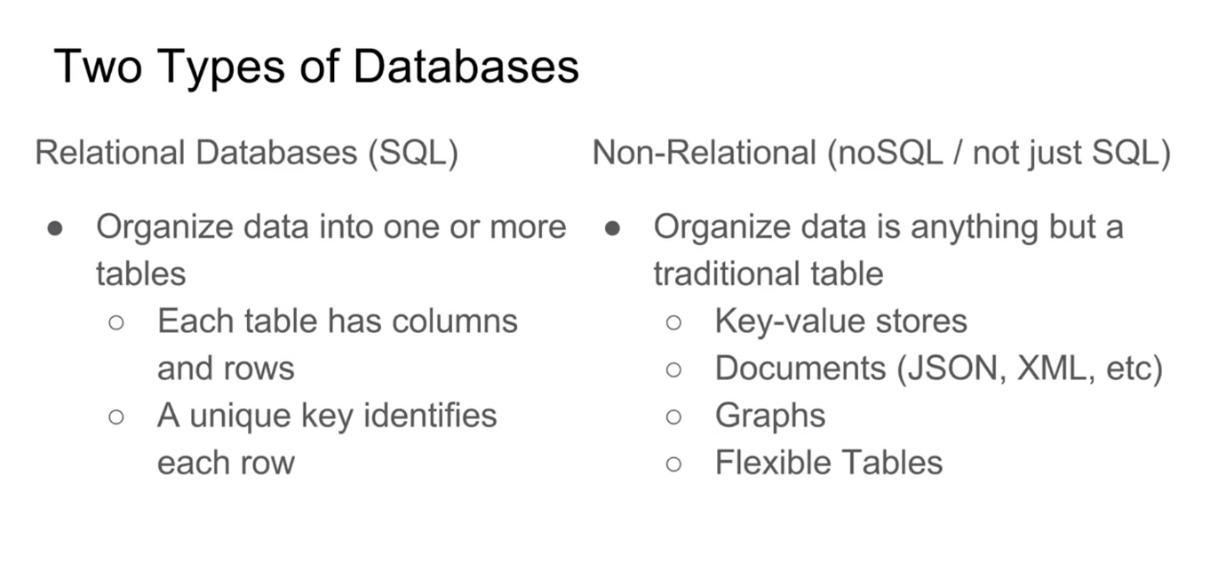

So, the first is called a relational database. You’ll hear people refer to these as SQL[Sequel] databases or S-Q-L databases. And then we also have what are called non-relational databases. And you’ll hear people refer to non-relational databases as no-SQL or not just SQL databases. We're going to talk about what SQL is in a second. But I want to show you guys these two types. So, a relational database which we have over here on the left, organizes data into one or more tables. So, each table has columns and rows and a unique key identifies each row. Now, relational databases are by far the most popular types of databases. And relational databases are going to store everything inside of these tables. So, we'll organize all the data that we want to store inside of these predefined tables and then we can just insert information into there. A relational database is a lot like an Excel spreadsheet. So, if you’ve ever used a spreadsheet where we have columns and rows and we're storing information, that’s essentially what a relational database is. And then over here on the right we have non-relational databases. And a non-relational database is basically just any type of database that’s not a relational database. So, like I said, relational databases are by far the most popular type. And so, because they’re so popular, any other type of database that’s not technically relational is just referred to as non-relational. And non-relational databases, you know, it’s very general. Because any database that’s not relational is getting put into this category. So, non-relational database is organized database in anything but a traditional table. So, you’ll have things like key-value stores documents which would be kind of like JavaScript Object Notation. Or like XML. They’ll store data in graphs. Or even flexible tables. So, really non-relational database is a very general category. It’s just anything that’s not relational.

So, let’s take a real quick look at a relational database.

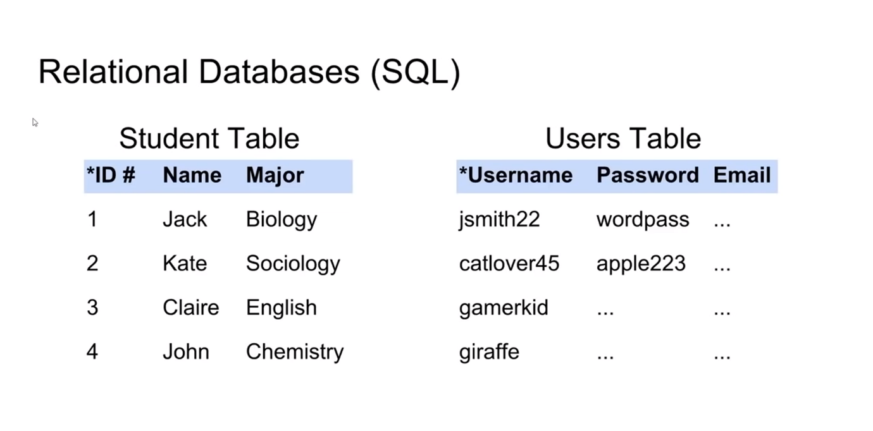

Or you’ll hear people, like I said, refer to this as a SQL database. So, over here, we have two examples of tables. So, this would be basically how we would store information in a relational database. So, over here I have a student table. And this student table might store individual students. So, you’ll see over here we have an ID, a name, and a major. So, for every single one of my students, I have an entry just like this. And you'll notice over here, I’m giving each of these entries an ID. And that ID will uniquely identify that row in the table. And over here, we have a users’ table. So, maybe you're creating users for your application. So, they have a username, a password, and then an email, right? So, the username is something that’s going to be unique. It’s something that uniquely identifies each row in the table. And then we're also storing like password and email. So, we kind of talked about how relational databases store data in tables.

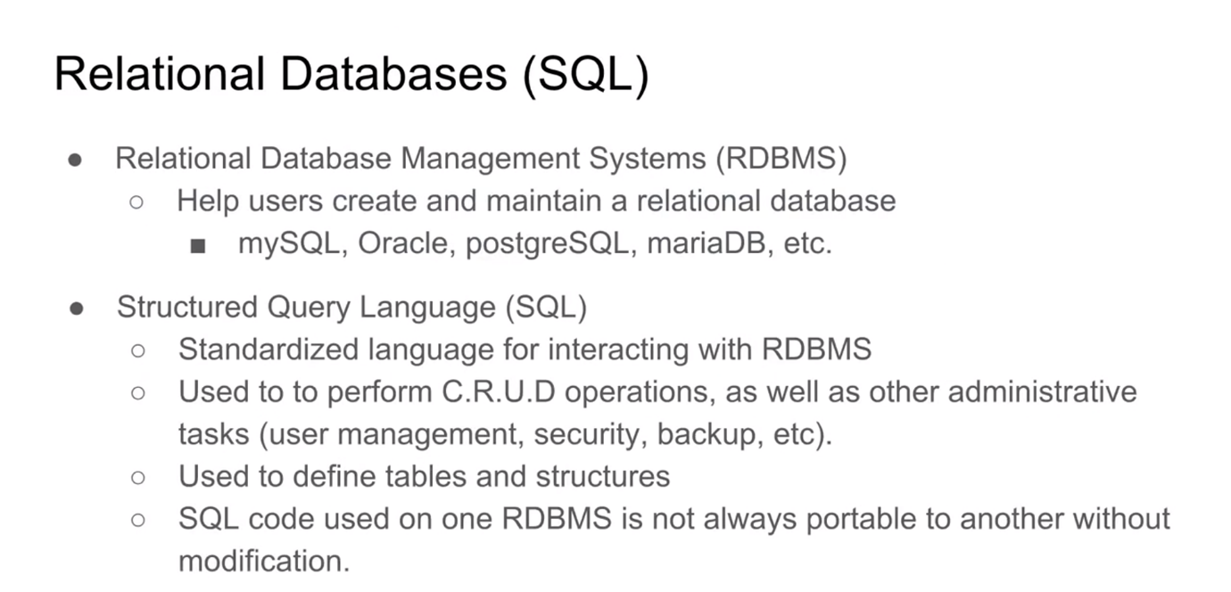

And when we want to create a relational database, we can use a relational database management system. And a relational database management system, or an RDBMS is just a database management system that helps you create and maintain a relational database. And some of the most popular are my MySQL, Oracle, PostgreSQL, and MariaDB. There’s a bunch of these that are, you know, extremely popular. And relational database management systems use something called Structured Query Language, or SQL. And SQL is a standardized language for interacting with relational database management systems. So, remember, a relational database management system is just a software application that we can use in order to create, maintain and do different things to our relational database. And SQL or Structured Query Language is the language that we can use to interact with those relational database management systems. So, we can use SQL to perform CRUD operations as well as other administrative tasks like user management, security, backup, etc. And we can use SQL to define tables and structures. So, a relational database uses tables in order to organize its information. And we can use SQL to define those tables. And then insert information into those tables. And SQL is a standardized language which means it’s pretty much used on every relational database management system. However, different relational database management systems will implement SQL just a little bit differently. So, not all SQL code that you use on one relational database management system will port over to another one without slight modification.

So, now let’s talk a little bit about non-relational databases.

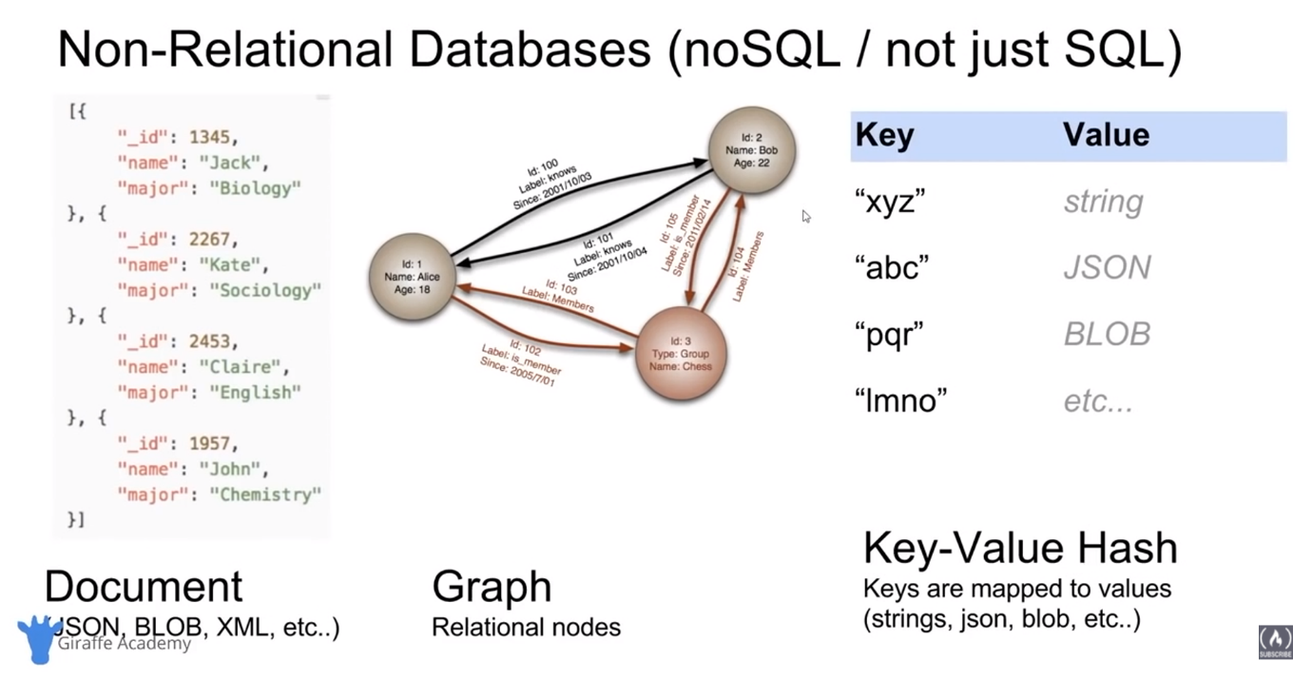

And in non-relational databases is just anything that’s not relational. So, a non-relational database stores data in anything but a, you know, a static table. So, I’m showing you guys a couple different examples of non-relational databases and how they would store data. So, over here we have a document database. And this would store information inside of like little objects or documents. So, we're talking about things like JSON or XML. Basically, I think JSON is kind of a very popular format and that’s kind of what I have up here. So, JSON is JavaScript Object Notation. So, there’s a lot of non-relational databases that will store data in documents just like this. They’ll also store data in graphs. So, over here we have graphs. And there’s like these little nodes. And then there’s, you know, connecting lines between the nodes which would represent like relationships. And then over here we have a key value hash. So, we would have a key and it gets mapped to a value. And that could really be anything. It could be a string. It could be JSON. It could be a graph. It could be anything like that. So, these are just three common examples of what SQL or non-relational databases might look like or how they might store their data. And just like with relational databases we can have non-relational database management systems.

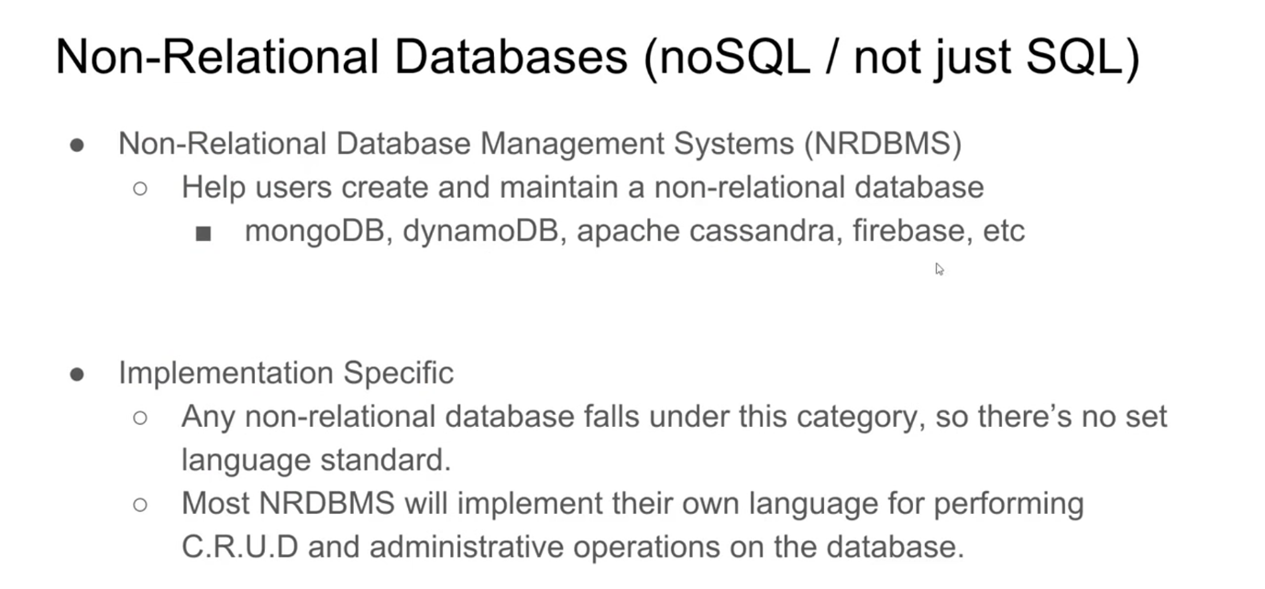

And these help users to create and maintain non-relational databases. So, some examples would be mongoDB, DynamoDB, apache cassandra, firebase. There’s a bunch of these popular noSQL databases that have been sprouting up over the last decade or so. And these are all implementation specific. So, unlike relational database management systems where we have SQL which is just a standard language that can interact with all of them, there isn’t a standard language for interacting with non-relational database management system. So, generally, the non-relational database management system will implement their own language for performing CRUD and administrative operations on the database.

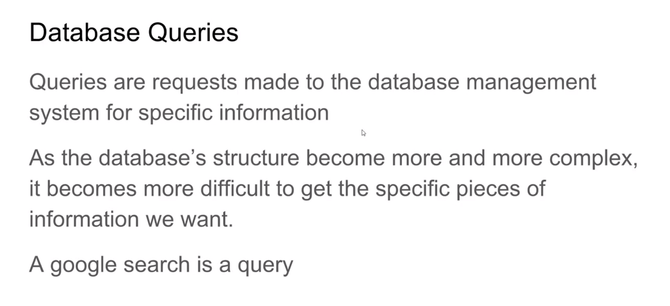

So, now that we've looked at the different types of databases, I want to talk to you guys about some core concepts within databases. So, one of the most common things that you’re going to be doing are queries. So, a database query is a request that’s made to the database management system for specific information. So, you’ll hear the word query thrown around a lot. And generally, a query is you’re just asking the database management system to give you some information. So, as a databases structure becomes more and more complex, it becomes more difficult to get the specific pieces of information that we want. And if you have a very complex database layout or schema, then getting a specific piece of information can be a little bit tricky. And that’s why we write database queries. So, can write a very complex database query which in a lot of ways is like a program, if you’ve ever used a programming language before. And that query will then instruct the relational database management system to grab a specific piece or specific pieces of information from the database. So, a good way to think of a query, is it’s kind of like a Google search, right? So, if I go on Google and I would generally type in the specific information that I want. And then Google would give me the information that matches that search query. That’s a lot like a database query. Except with a database query, we're not going to be writing the query in English like we would with Google. So, I can, you know, go up to my Google search bar and I can type something in in English or Spanish or whatever language you speak. But with a relational database management system we have to write our queries using either SQL or a specific language that’s meant for that database management system.

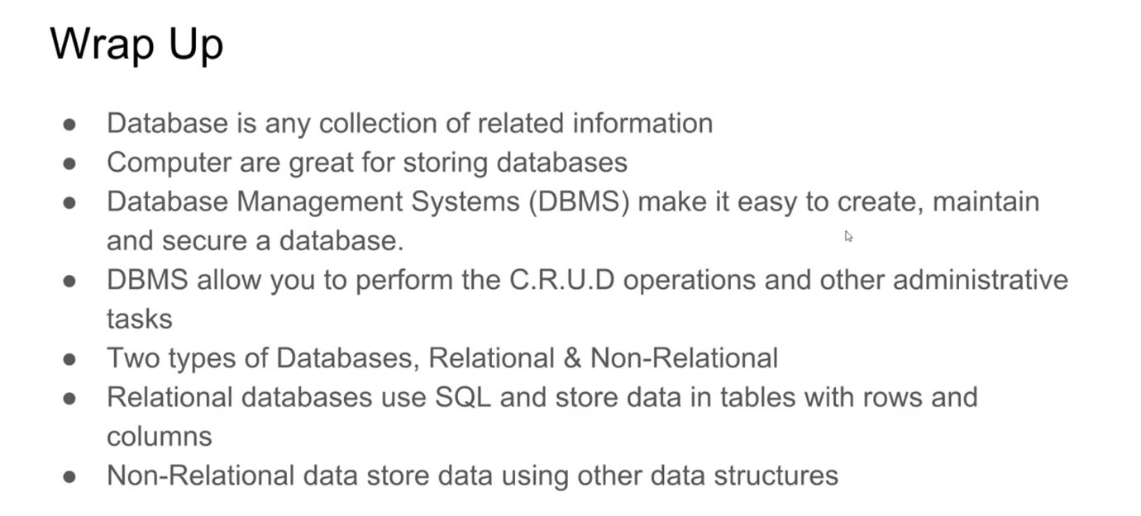

So, let’s wrap this up with a real quick. We kind of covered a lot of the main points with databases. So, a database is any collection of related information. It’s a very general term. And computers are great for storing databases because computers are really fast. They can store lots of pieces of information. And they can handle things like security really easily. And database management system makes it easy to create, maintain, and secure a database on a computer. Database management systems will allow you to perform the CRUD operations and other administrative tasks on the database. There are two main types of databases, relational and non-relational databases. Relational databases use SQL and they store data in tables with rows and columns. Non-relational databases store data using other data structures. So, things that aren’t relational database tables. And then we talked a little bit about querying. A query is just a request that you would make to the database management system for a specific piece of information. So, that is kind of the basics, the overall high-level basics of databases. And really, if you understand everything in this PowerPoint, then you have a good grasp of database fundamentals. And as we go forward, we're going to learn more and more things about databases like how to create them, how to store data, and how to organize our data so that it’s easy to retrieve when we want it.

**Tables and Keys:**

[Tables and Keys] In this tutorial, we're going to look at some of the core concepts in relational databases. So, we're going to talk about how we store information in relational databases. Namely, in tables. Let’s talk about the different things about those tables. We're going to talk about things called keys. We're also going to look at rows and columns. We'll talk about different tables can be related to each other and how we can define relationships between tables. So, this will really just give you guys a full introduction into some of the core concepts of relational databases which you can then apply when creating your own relational database using a relational database management system. So, let’s get started. Over here I have an example of a table. And this is a student table.

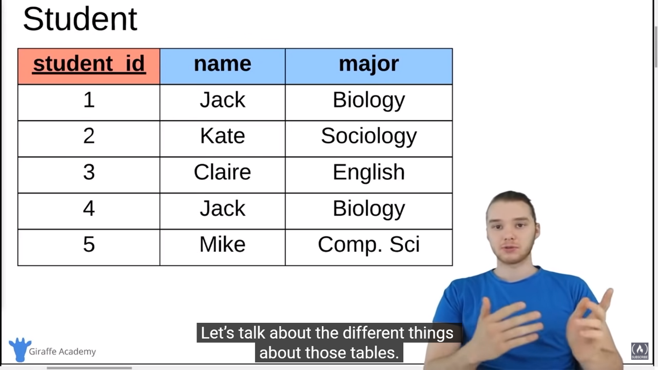

And so, the student table defines specific information about a student. So, up here we have the column names. So, the student ID, the name of the student, and then the major. So, I’m storing three pieces of information about each student, right? They have their ID, their name, and their major. So, over here we have Jack. His student ID is 1. And he’s majoring in biology. Down here, we have Claire. Her student ID is 3 and she is majoring in English. So, all tables in relational databases are going to have two things. They’re going to have columns and they're going to have rows. Now, columns are these vertical sections right here. So, a column would define a single attribute, right? So, we have our name column. And inside the name column we have the names of all the students. We have the major column. Inside the major column we have the majors of all the students, right? Makes sense. And then we have rows. And a row is an individual entry in the student table. So, a row or a horizontal entry would represent a single student, right? So, in a single row we're storing the student ID, the name, and the major. So, the columns represent a single attribute and the row represents an entry or an actual student.

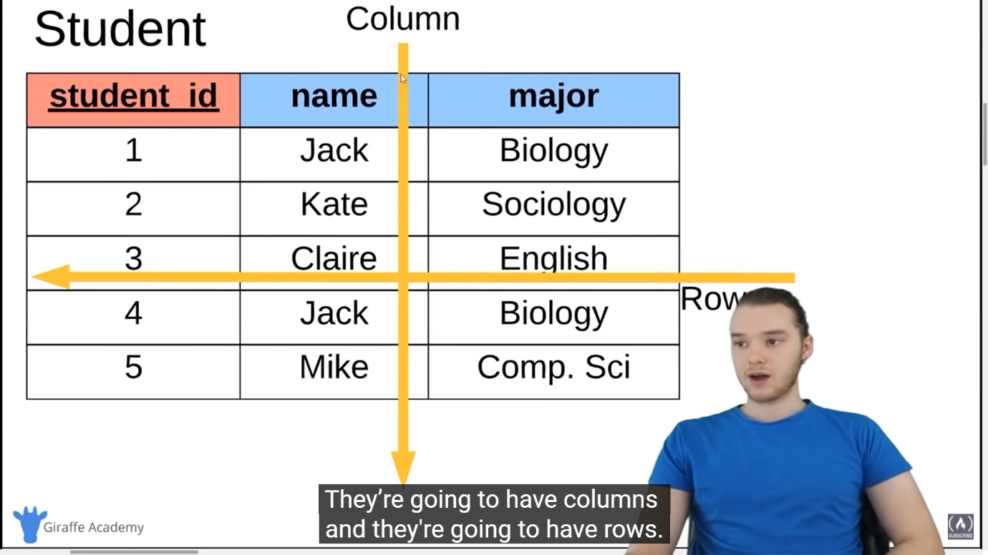

Whenever we're creating a table in a relational database, we always want to have one very special column which is called the primary key. And a primary key is basically an attribute which uniquely defines the row in the database. So, it’s an attribute about a specific entry which will uniquely define it. So, over here, we have student ID.

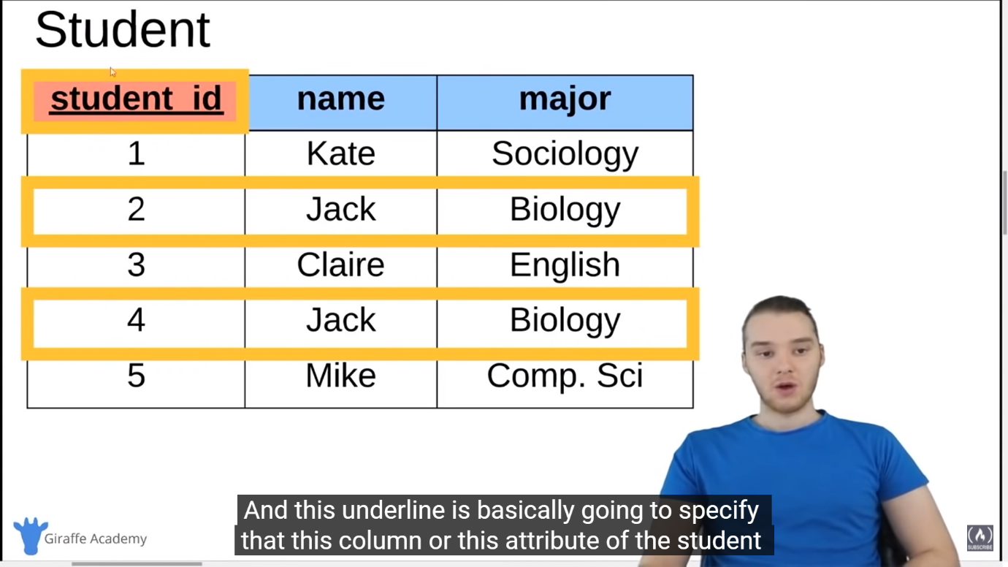

And notice that I coloured this in red and I also underlined it. And this underline is basically going to specify that this column or this attribute of the student is going to be the primary key. In other words, we can use this attribute to uniquely identify a specific row. So, over here we have Kate and she’s a sociology major and her ID is 1. So, we would say that Kate’s primary key is 1. Now, let me show you why primary keys can come in handy. So, down here, inside of these gold squares I have two entries in this database.

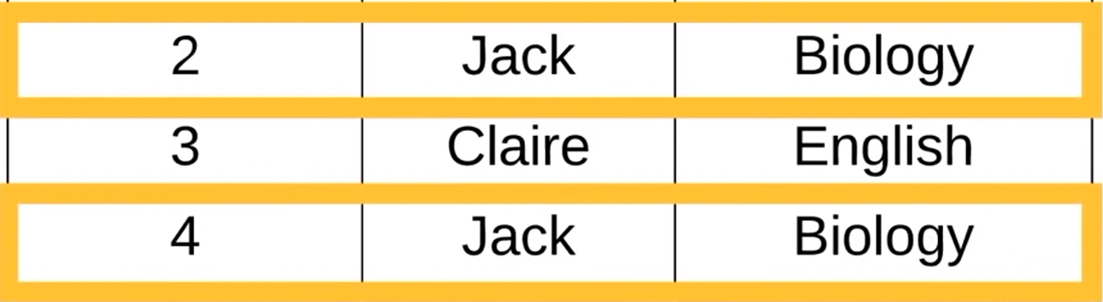

So, we have two students, both of which are named Jack. And both of which are biology majors. Now, this isn’t that, you know, special of a case, right? You can imagine that in a school you might have two students with the same name who are the same major. But in this case, how can we differentiate between this guy and this guy? Well, we can use this primary key. So, even though the name and the major of this row in the table are the same as the name and the major of this row, the student ID is different. The primary key is different. And that’s the whole point of a primary key, is that the primary key is always going to be unique for each row in the table. So, even if all of the attributes of the row are the same, the primary key won’t be. And therefore, we can differentiate between the two rows. So, I can differentiate between this Jack and this Jack by referring to their student IDs. And so, generally, whenever we have a table in a relational database, you always want to define a primary key. And a primary key can be anything. It can be a number. It could be a string of text. It could really be anything that you want. But it has to uniquely identify the specific row. So, in other words, another row in this student table couldn't have a primary key of 2.

So, down here I have another example of a database table. This is a user table. So, just like that student table, except it is storing information about users.

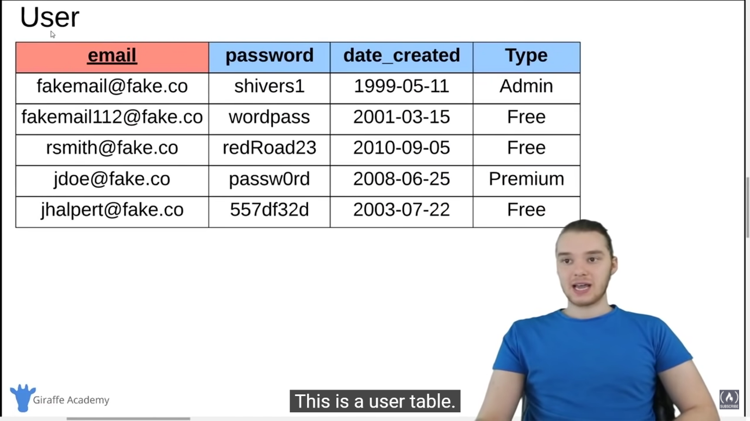

So, over here we have email, password, date created and type. So, email is going to be our primary key. You can see I put that in red and I also underlined it. And these emails are unique to each entry in the table, right? So, fakemail@fake.co. No, other rows in this table could have that exact email. 

And then over here we're storing the password. We're also storing a date. So, a lot of times in databases you can store date values or time values. And then over here we're storing a type. And so, basically whenever you want to store data, what you’re going to do is define a table. So, you’re going to define, you know, all this information up here and then you'll just insert specific pieces of information into that table.

And so, over here we have one more example of a database table. And we're actually going to be looking at this example as we go forward. So, this is an example of an employee. So, imagine that we have like a company database and we were storing information about employees.

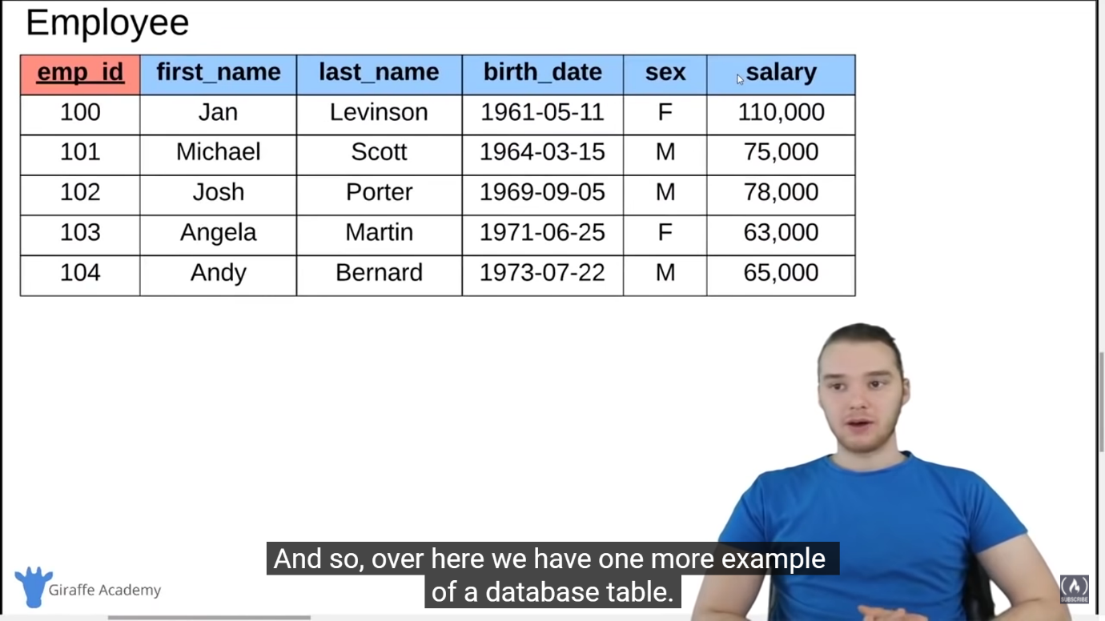

So, we have the employee ID which is the primary key. We're storing first name, last name, birthdate, sex, and salary. And we're storing all of this specific information about an employee. Now, I want you guys to notice the primary key over here. So, employee ID, this is just a, you know, some sort of random number that we’ve assigned to each employee, right? This employee’s ID is 100. This employee ID is 101, etc. And this over here, this employee ID, this is what we would call a surrogate key. And a surrogate key is basically a key that has no mapping to anything in the real world, right? It’s essentially just, you know, like in this case a random number that we assign to an employee, right? So, this, employee Jan has an employee ID of 100. That doesn’t necessarily mean anything. 100 is just a value that we're using to represent Jan inside of the database. And so, we would refer to that as a surrogate key, which is just a type of primary key. Surrogate key is a key that has no mapping to anything in the real world. We can also have something called a natural key.

And over here you'll see that I have the same exact table except instead of having employee ID, I have employee SSN.

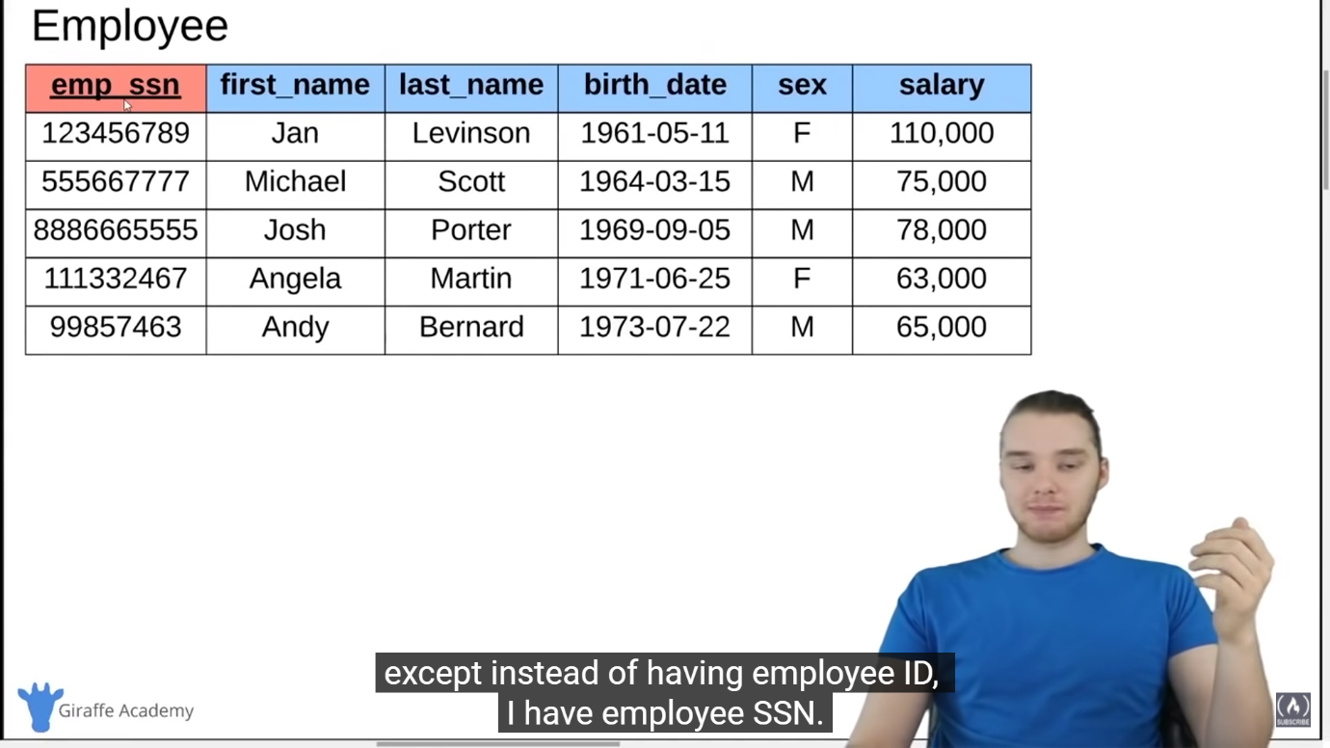

And SSN stands for Social Security Number. So, Social Security Number is a number that we use here in the United States in order to uniquely identify each citizen. So, in this case we're using the Social Security Number in order to uniquely identify each row in the table. In other words, we're using the Social Security Number as the primary key of the table. And this is an example of what we would call a natural key. And this is a key that has a mapping or has a purpose in the real world, not just in the database. So, a lot of times you'll hear people refer to surrogate keys or natural keys and that’s the difference. A surrogate key is a primary key that has no mapping to the real world. And a natural key is a key that has a mapping to the real world, just like Social Security Number. So, those are kind of the two different types of primary keys that you might see being stored. Another thing I want to talk to you guys about are what are called foreign keys.

And a foreign key is basically an attribute that we can store on a database table that will link us to another database table. So, over here I have this same exact employee table.

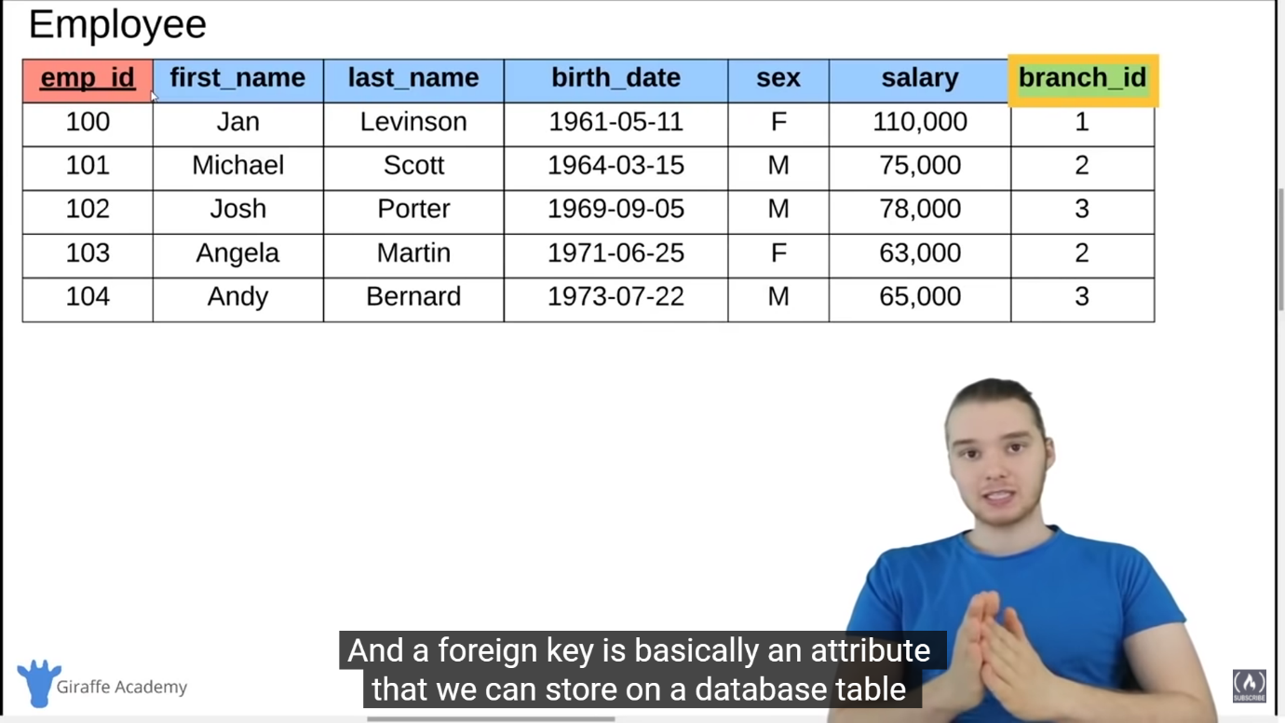

And then I also have this other attribute over here, branch_id. And you notice that I coloured this in green. And this is what we would call a foreign key. And a foreign key stores the primary key of a row in another database table.

So, here we have our employee table and I’m defining information about the employee. But let’s say that an employee belongs to a specific branch in our company, right? So, a company might have different branches. And we can store the information about what branch the employee belongs to inside of a foreign key. So, the foreign key over here is actually a primary key inside of another table.

In our case, a branch table. So, let me show you guys that. So, down here, we have this branch table in our database, right?

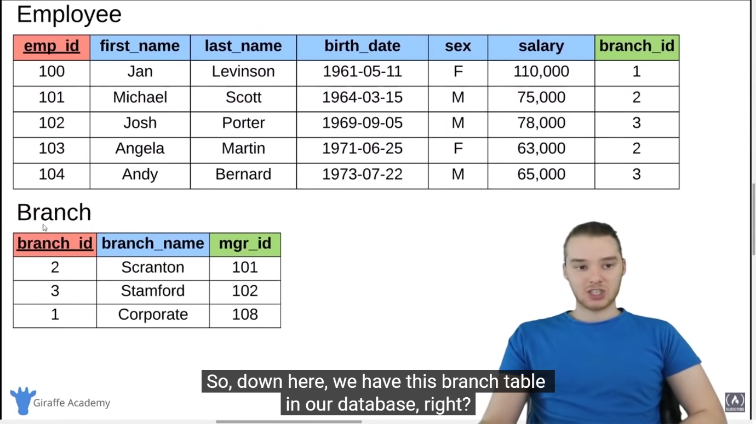

So, the branch has its own separate table. And we have – the branch has a primary key over here which is 2, 3, 1. And the branch names are Scranton, Stamford, and Corporate. So, this in itself is its own table, right? It’s the branch table. And over here we can define which branch a specific employee belongs to, by referring to the ID, the primary key of the branch. So, here, Jan Levinson, her branch ID is 1, which means she is in the corporate branch, right? Because branch ID number 1 is corporate. Michael Scott, his branch ID is 2, which means he’s in the Scranton branch. So, this number is mapping this row over here into this other table. And that’s what a foreign key does. A foreign key is essentially just a way that we can define relationships between the two tables. So, a foreign key is just a primary key of another table. So, Andy Bernard, right? His branch ID is 3 which means he belongs to the Stamford branch. And so, that’s what a foreign key does.



A foreign key allows us to link up or define relationships between tables. I can say that Andy belongs to the Stamford branch and I can define that using the foreign key.

And over here you'll see on the branch table, I also defined another foreign key which is manager ID. mgr_id, that would stand for manager ID. And now this is actually going to be a foreign key which connects branch to the employee table. So, manager ID is going to be the ID of a particular employee who is the manager of the branch. So, let’s take a look at the Scranton branch. So, the branch ID is 2. The name of the branch is Scranton, and the manager ID is 101. So, let’s go check it out. So, over here in the employee table, employee 101 is Michael Scott. What that means is that Michael Scott is the manager of the Scranton branch, right?

We were able to define that relational by using these foreign keys. So, down here, the Stamford branch, the manager is 102. If we come up here, we can see employee 102 is Josh Porter. So, Josh Porter is the manager of the Stamford branch. Corporate over here, the manager ID is 108. So, over here we didn’t actually include 108 over there. So, obviously, this isn’t like, you know, a huge table of employees. But the manager for the corporate branch would be the employee with the ID of 108, whatever that would be inside of this table. So, that’s what a foreign key does. A foreign key is able to help us to define relationships between the tables, right? I can define which branch a specific employee belongs to by including the branch’s ID as a foreign key in the employee table. Similarly, I can define which employee is the manager of a branch by including that employee’s ID as a foreign key in the branch table.

And so, that’s really why foreign keys are going to come in handy. And it’s also important to note that a particular table can have more than one foreign key on it. So, over here I have my employee table, right? And it’s the same exact thing as we have before.

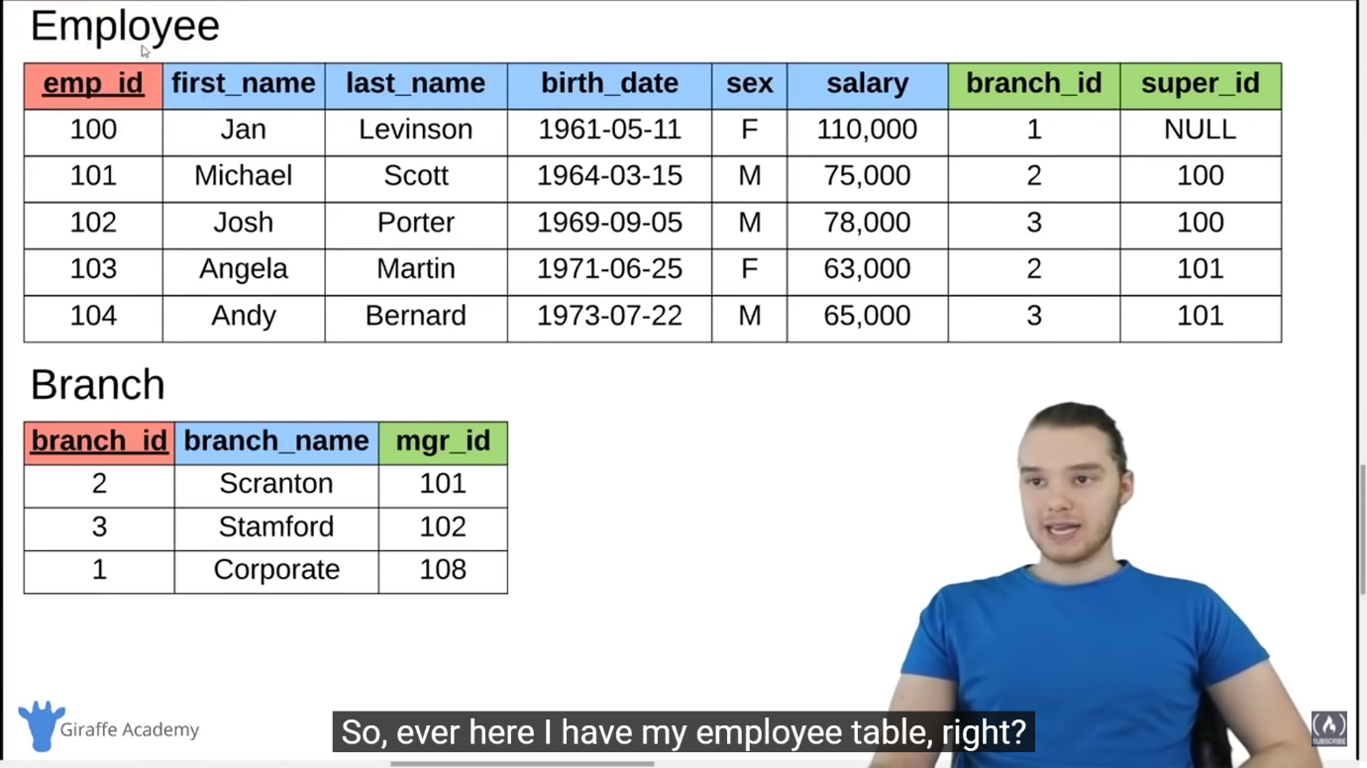

But I also added another attribute or other column over here which is super_id. And that stands for supervisor ID. And so, what this is going to do is it’s going to define who is the supervisor of a particular employee. And what’s cool about this foreign key is it’s actually relating back to the same table. So, an employee can be a supervisor of another employee. So, over here we have Angela Martin, right? Her employee ID is 103. And her supervisor ID is 101. And that means her supervisor is the employee with the ID 101.

So, if we come over here and take a look at this, Angela Martin’s supervisor is Michael Scott because Michael Scott has an employee ID of 101.



So, Michael Scott. Michael Scott’s super ID is 100. That means Michael Scott’s supervisor is the employee with ID 100, which is Jan Levison. So, we can have this foreign key over here on the employee table to define relationships between employees.

So, before, we were defining the relationship between the employee table and the branch table, and now we're defining a relationship between the employee table and the employee table, right? And so, what’s cool about this is, that basically inside of this table, we can tell what the different supervisor or supervisee relationships are, right? I can tell that Josh Porter’s supervisor is Jan Levinson. And I can tell that Angela Martin’s supervisor is Michael Scott.

All right, so let’s take a look at another table. I actually added in another table down here. So, over here we have employee, just like we had before. We have branch. And then we also have branch supplier. And branch supplier is another table that we can look at.

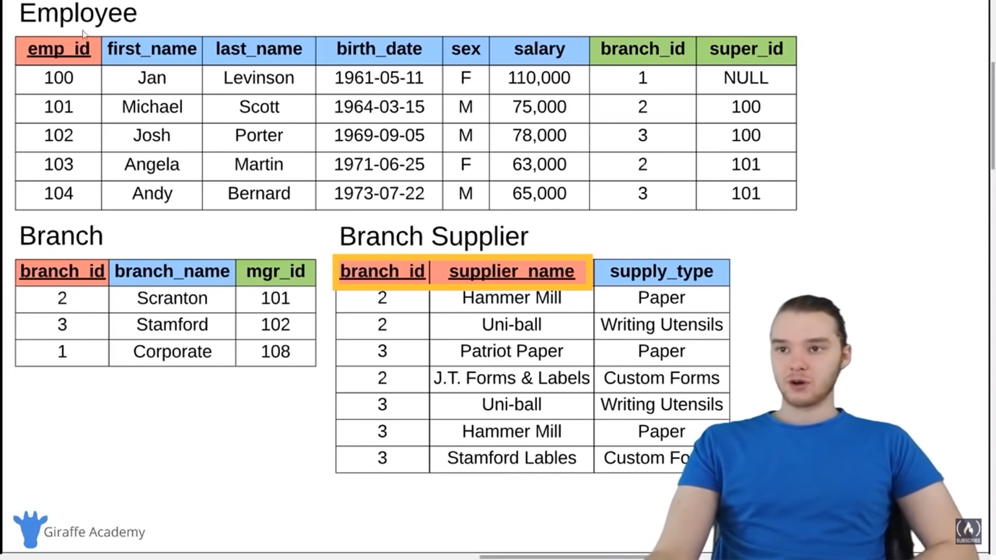

So, a branch supplier would basically define who the suppliers are for specific branches. So, we have these branches. Maybe they're selling a certain product. Maybe they're selling like paper products. And the branch suppliers would define who are the suppliers for that branch. And you'll notice up here, the primary key actually consists of two columns. And this is what we would call a composite key or a composite key. And a composite key is basically a key that needs two attributes. So, this key is made up of two columns, right? It’s made up of branch_id and supplier_name. So, branch_id is actually going to refer to the specific branch. And supplier_name is going to refer to the specific supplier, right?

So, we can say over here that Hammer Mill supplies paper to branch number 2. So, Hammer Mill supplies paper to Scranton. Uni-ball supplies writing utensils to branch ID number 2, which is Scranton. Patriot Paper supplies paper to branch ID number 3 which is Stamford. So, inside of this branch supplier table, I’m able to define which different suppliers are supplying what to which different branches. Now, the reason that I need this composite key or this composite key, is because the supplier_name doesn’t uniquely identify each row. And the branch_id doesn’t uniquely identify each row. Only together can they uniquely identify each row, right?

So, for example, supplier name, Hammer Mill.

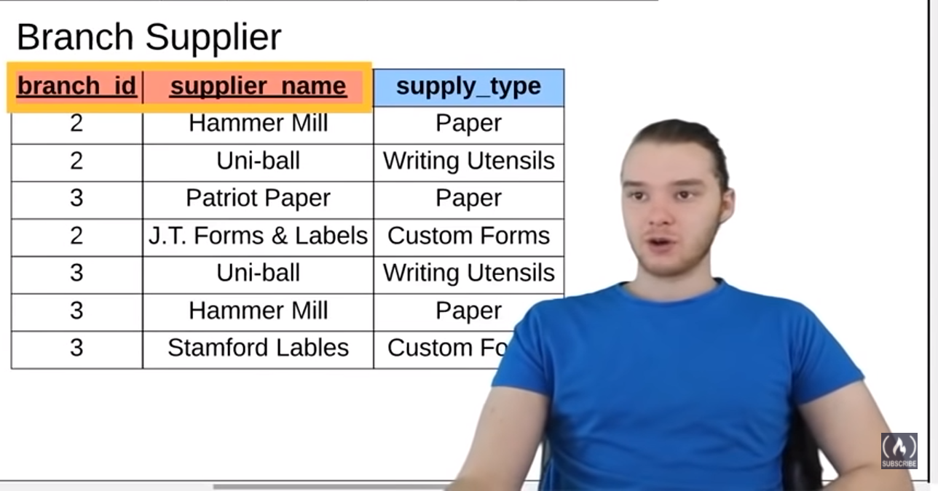

You’ll notice that Hammer Mill shows up here and it also shows up here. So, Hammer Mill supplies to branch number 2. And they also supply to branch number 3. Uni-ball supplies to branch number 3 and Uni-ball supplies to branch number 2. So, the supplier_name column has repeated values, right? This column has Hammer Mill repeated. It has Uni-ball repeated. branch_id also has those things repeated, right? So, branch_id 2 shows up here a bunch of times. branch_id 3 shows up here a bunch of times, right? And so, the branch_id column can’t uniquely identify the table. And the supplier_name column can’t uniquely identify the table. Only together can they uniquely identify it, right? So, we would say Hammer Mill supplies branch 2. That combination only shows up once. We wouldn't put that combination again because we’re already defining it. So, Hammer Mill supplies branch 2. Hammer Mill supplies branch 3. These two rows are uniquely identified by the identified by the supplier_name and the branch ID.

And so, over here in these (employee and the branch) tables, we only find one column as the primary key.

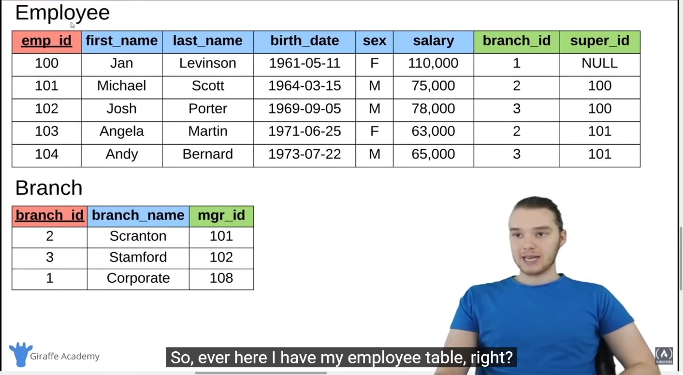

But over here, we define two columns as the primary key, which would be a composite key. And that’s actually pretty common, where we're going to have two columns uniquely identifying each row.

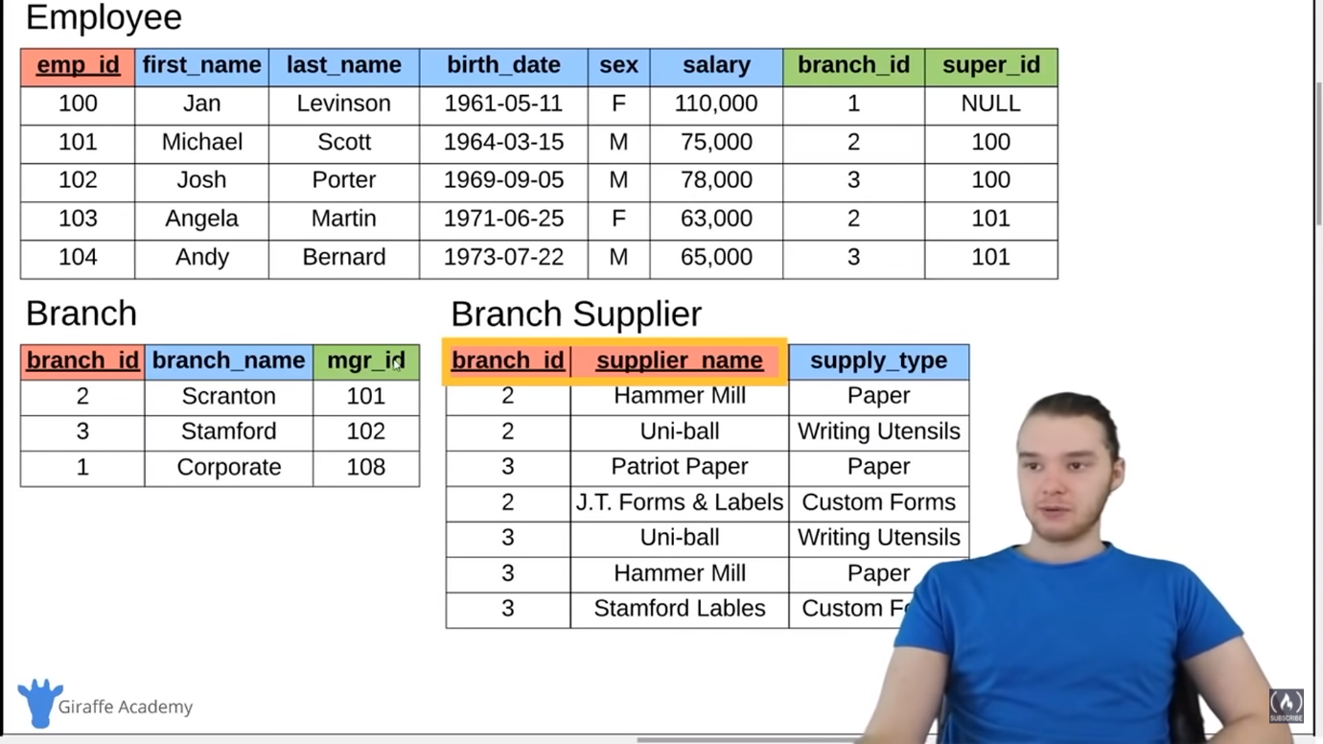

All right, so down here I want to show you guys one more example.

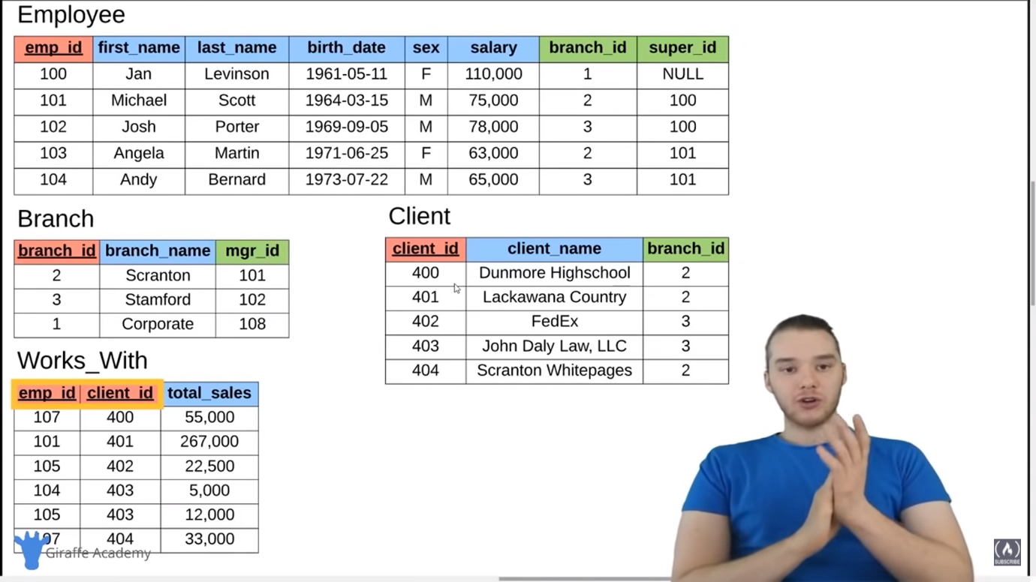

And this is going to show you one other way that we can define like different relationships with these tables. So, I actually added in two other tables. We have a client table and we have this Works With table. So, let me kind of walk you guys through this a little bit. We still have employee. We still have branch. But over here, we're defining clients. And so, a client might be like a customer, right? So, a client would buy paper products or, you know, whatever products from the branch and employee. So, the client has a client ID. They have a client name. And then they also have a foreign key which is a branch ID.

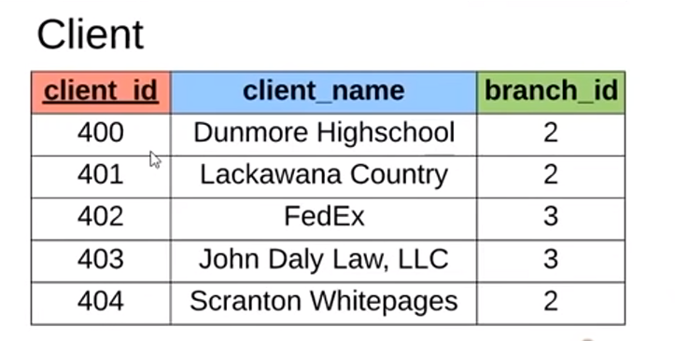

So, a client is going to be associated with a specific branch, right? So, we would say Lackawana County is associated with branch 2. Which means the Lackawana County is going to buy products from the Scranton branch. The John Daly Law, LLC is going to buy products from branch ID number 3. So, they're going to buy products from the Stamford branch, right? So, this is a client table. And down here, we have this Works_With table. And what the Works_With table is doing is it’s defining the relationships between the employees and the clients.

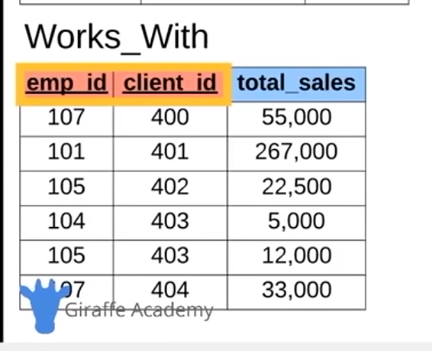

Namely, how much paper an employee sells to a specific client. So over here we have employee ID.We have client ID. And we have total sales. So, the employee ID is going to refer to an employee in the employee table. The client ID is going to refer to a client in the client table. And then we're going to define how much in product the client has bought from the employee. So, employee 101, for example, that is Michael Scott. Michael Scott has sold client ID 401. Michael Scott has sold Lackawana County $267,000 worth of product, right? How about this one, 104. So, Andy Bernard has sold client number 403 – has sold John Daly Law $5000 in paper products. And so, this Works_With table is able to define how much an employee has sold to a client. And you'll notice over here we have a composite key. And the composite key is employee ID and client ID.



And this is actually a special type of composite key because both of these columns are actually foreign keys. So, employee ID is a foreign key, right? It relates to the employee table. Client ID is also a foreign key. It relates to the client table. And both of those foreign keys together make up the primary key of the table. And that is actually a very useful way to define a primary key. Because when we do something like this, we can define a relationship, right? So, I can define how much product the client has bought from the employee. And that is something that can because were useful to keep track of.

So, as you can see, like these tables can either be very simple or they can be very complex. And the more complex your database design or your database schema is, the more complex these tables and these keys are going to have to be, right? So, this employee table has a primary key and two foreign keys. The client table has a primary key and a foreign key. This Works_With table has a composite key. You know what I mean? Both of which are foreign keys. Like it can get very complex, but we can use the primary keys and the foreign keys in order to define different relationships. But really, that is just a, you know, I think a pretty good introduction into kind of how tables work. We talked about rows and columns. We talked about primary keys. We talked about surrogate keys and natural keys. You know, the different types of keys that might map to the real world or not. We talked about foreign keys. We talked about composite keys. And I kind of showed you guys a few different examples of ways that things might work. So, this would be like our company database. And obviously, we would have a lot more information in here. But this is kind of a good example of how we might define different tables and then define the relationships between those tables in a relational database.

**SQL Basics:**

[SQL Basics] In this tutorial I’m going to walk you guys through SQL which stands for Structured Query Language. So, SQL is a term that you're going to hear, thrown around all the time when you're talking about databases. And SQL actually is a language. And it’s a language that’s used for interacting with relational database management systems.

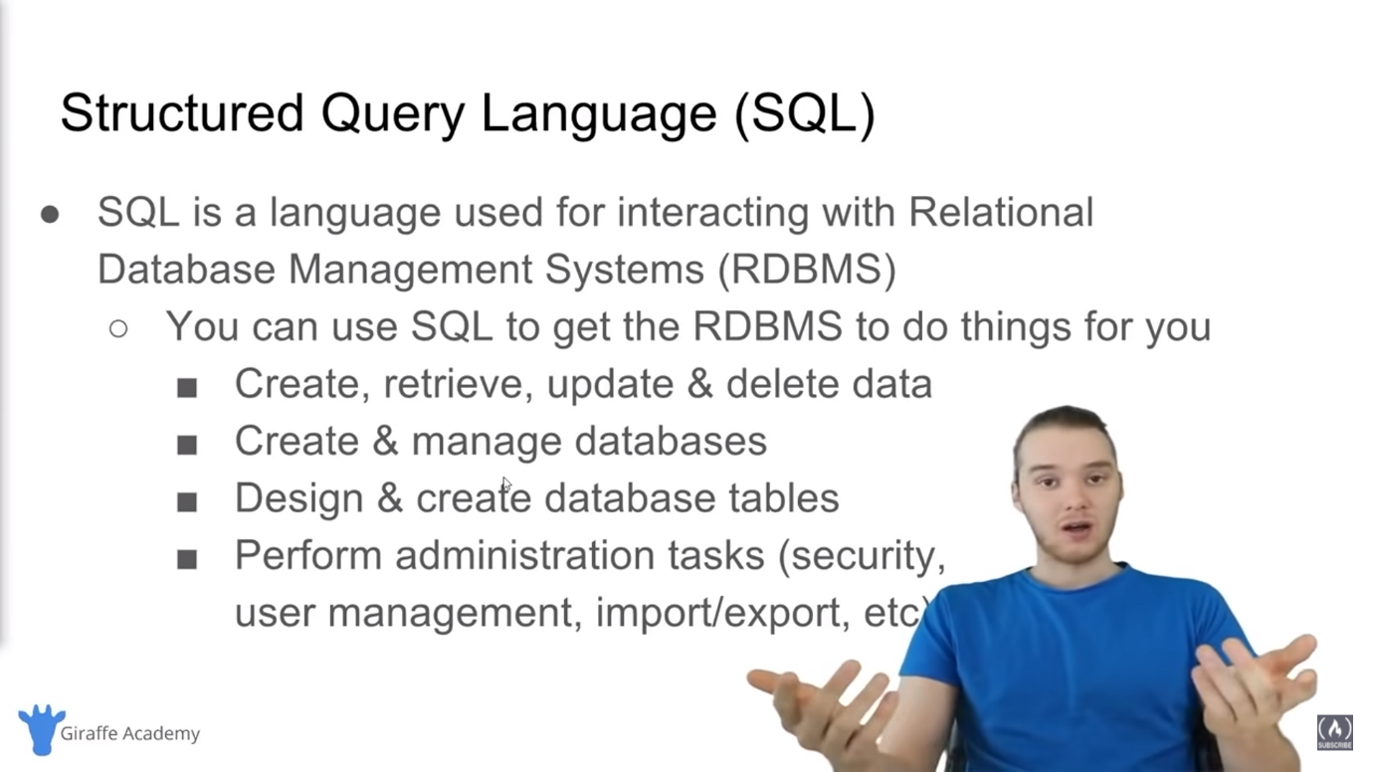

So, SQL is – it’s similar to – kind of like a programming language. A lot of times you’ll hear people refer to SQL as a programming language. It’s not technically a programming language in the tradition sense. Although, you can use SQL to provide instructions to a relational database management system. So, I guess if you want, you could call it a programming language. So, like I said, SQL, it’s a language that’s used for interacting with relational database management systems.

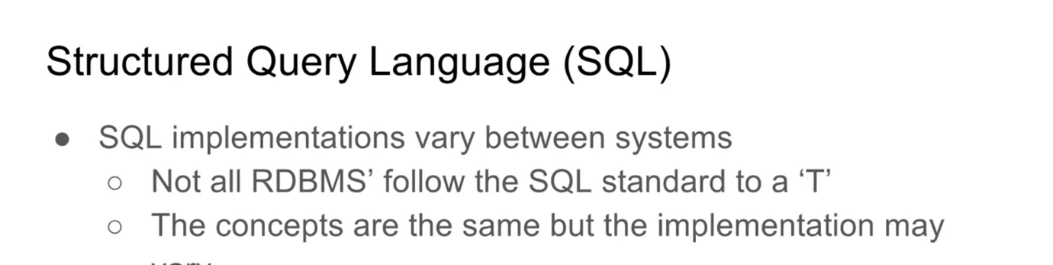

A relational database management system is a piece of software. It’s a software application that you can use to create and maintain a relational database. You might use a relational database management system to create a database for an application that you're building. And then that relational database management system can make sure that the database is structured correctly and store everything the way that it needs to be stored. So, in order to interact with a relational database management system, we need to use a special language. So, I can’t just talk to it in English. I can’t just be like, “Hey, relational database management system, get me this piece of information.” Relational database management systems don’t speak English. But what they do speak is a language called SQL. They speak Structured Query Language. And so, if we want to ask a relational database management system to do something for us, for example, like store a piece of information or create a table, update a piece of information. We can ask the relational database management system to do that using SQL. So, SQL is the language that we can use to communicate with the database management system. And, you know, we can use SQL to get the relational database management system to do stuff for us, like create, retrieve, update, and delete data. Create and manage different databases. Design and create database tables. So, we can define like a database schema which would just be like the overall like table design. And perform administrative tasks. So, things like security. We could do like user management, importing, exporting, backup, all that stuff. So, SQL can be used to tell the relational database management system to do all of that stuff for us. Now, here’s the thing, SQL implementation can vary between the systems. So, SQL, the actual language actually does have a formal specification. So, there is like an overall formal specification which defines, you know, how SQL needs to be used and all the different commands that can be used. But the problem is that there’s a bunch of these relational database management system. Some of the popular ones we hear about, like Postegres, MySQL, Oracle, Microsoft SQL Server. Like all of these relational database management systems are going implement SQL just a little bit differently. So, you could write SQL code that would work on one relational database management system, but then if you tried to use it on another one, it might not work 100%. Now, for the most part, everything should be the same, but you might just need to tweak a couple little things. So, one thing you want to keep in mind with SQL is that, you know, SQL is used on all of the major relationship database management systems, but it’s used slightly differently. So, certain instructions might work on one database management system and they might not work on another, or vice versa. Or you might do things just a little bit differently, depending. But for the most part, they’re all implementing SQL which means it’s all basically the same. So, the concepts are the same but the implementation may vary just a little bit.

So, let’s talk a little bit more about SQL. It’s actually a hybrid language. So, it’s basically four types of languages in one.

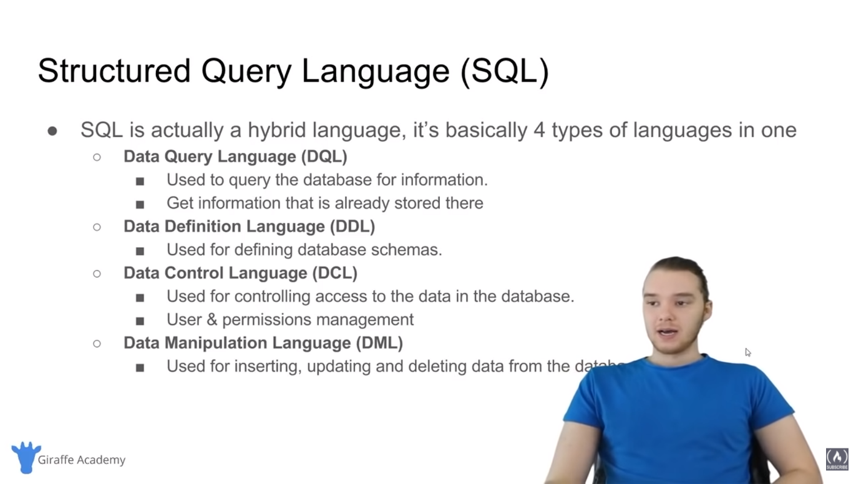

And you know, you don’t need to worry too much about all this stuff, but you are going to hear people talking about these different aspects of SQL. And so, I want to introduce them to you so you understand what they are. So, SQL, you know like I said, it’s four types of languages all mashed into one single language. So, SQL is a data query language, which means it can be used to query the database for information. So, you can write queries in SQL which tell the relational database management system what pieces of information that you want to get from the database. And so, a data query language is used to get data that’s already stored in the database. SQL is also a data definition language. And what that means is you can use SQL to define database schemas. Now, a schema is basically just like the overall layout of the database. Like what tables are going to be in the database, what columns those tables are going to have, and the data types that those columns are going to be able to store. So, we can use SQL to define data in the different, like I said, database schemas. SQL is also a data control language which means it’s used for controlling access to the data in the database. Basically, you can use it to configure like users and permissions. So, I could define a bunch of different users for the database. And I can say like, okay, this user can write to this table. Or this user can read information from this table. Or this user can update and delete information from this table. So, you can use SQL to control the access to the data. And SQL is also a data manipulation language. So, it’s used for inserting, updating, and deleting data from the database. So, these are the four different types of things that you can do with SQL. And you'll hear people using these terms kind of a lot. And even like database management systems might throw error messages or certain things. And they'll say like data query language or data definition language. So, it is good to just understand these different types of things that SQL can do and how they're broken up into these four like broad types of languages. But basically, the whole point of this slide is that SQL can do a bunch of stuff. And it’s super powerful. And that’s one of the reasons why it’s used in all these relational database management systems.

So, now let’s talk about queries. And one of the things that we're going to be doing a done of in this course, and you know, if you’re working with databases, you’re going to be doing this all the time, which is querying. So, query is a set of instructions given to the relational database management system generally written in SQL, that tell the RDBMS what information you want it to retrieve for you. So, if you have a database that has like millions or billions of records in it, like there’s tons of data. And a lot of times that data is, you know, spread out across different tables, right? It’s sort of hidden in this complex schema. You know what I mean? Like you have one piece of information stored over here and then another piece over here, another piece over here in different tables. And you want to kind of grab all that information and organize it in a specific way. We can use queries in order to tell the RDBMS to do that for us.So, the goal of writing a query is that we only want to get the information that we need, right? Imagine that if you, you know, every time you wanted a piece of information from the database you had to grab all of the information in the database, parse through it, and then find the information that you want. We don’t have to do that. Instead, you can write a query which will tell the RDBMS exactly what piece of information you want and it’ll be able to grab just that information and send it back to you.

So, over here I just have a little example of a query. So, this would be like maybe we're trying to get – this would be SELECT employee.name, employee.age.

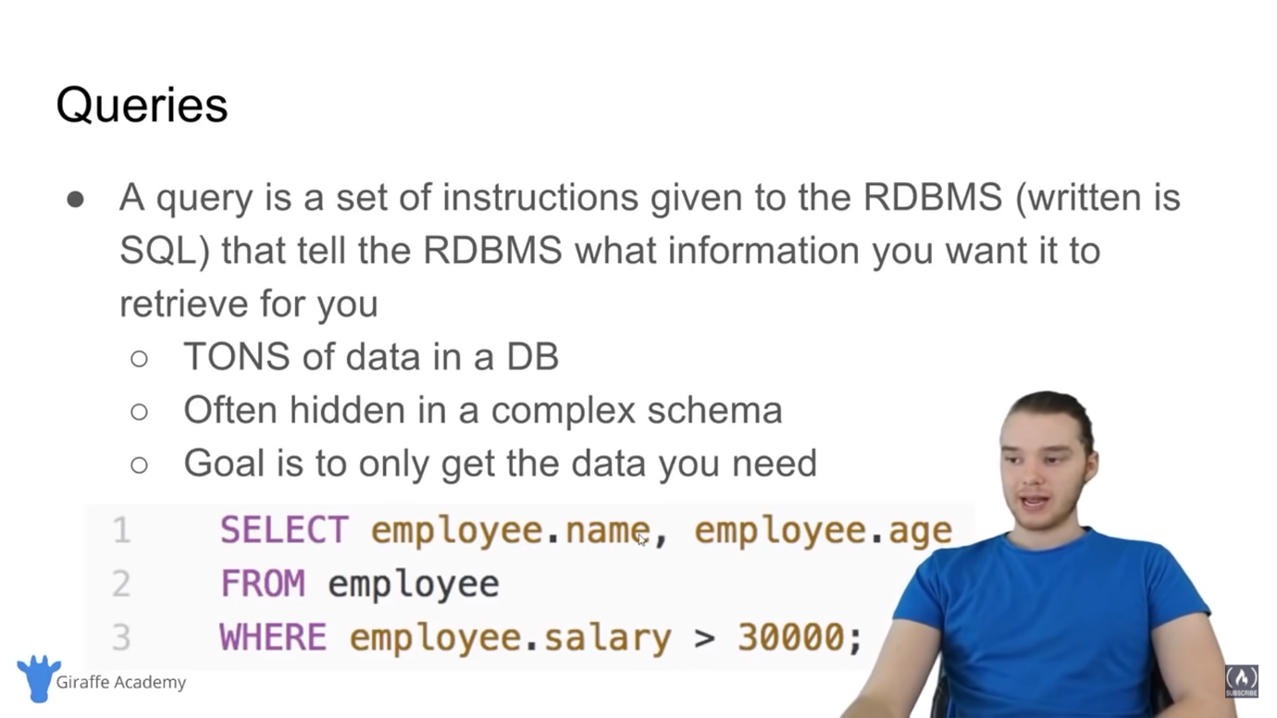

So, select the employee’s name and the age from the employee table where the employee’s salary is greater than $30,000. So, what this will do is it’ll give us every employee in an employee table who makes more than $30,000, right? That’s kind of like a general query. Don’t worry too much about specifically what all this stuff means. We're going to get into that in this course. But that’s kind of like what a query would look like. We're telling the RDBMS what information we want and then it only gives us back that information. Not like all the information in the database. All right, so that is kind of an overview of SQL. I mean obviously I didn’t get into everything. We're going to look at all of these, you know, little specific things that we can do with SQL as we go forward. But for now, that should kind of give you an idea of what SQL is, why it’s useful, and you know, sort of what it’s doing for us and how we can use it to work with our databases.

-----------------youtube 52:25 and also in the notepad 52:25--------------

MySQL Windows Installation

PopSQL installation

MySQL Mac installation

<https://www.youtube.com/watch?v=HXV3zeQKqGY&t=3146s>

-----------------youtube 1:15:49 and also in notepad 1:15:44--------------

[Creating Tables]

In this tutorial I’m going to talk to you guys about datatypes. We're going to talk about creating tables. We're also going to talk about altering and deleting tables. So, in the last tutorial we set everything up. So, we got MySQL set up. We also downloaded this program PopSQL which is basically just a text editor that we can use to write all of our SQL code and all that stuff. So, what I want to do in this tutorial is show you guys how to create tables, right? So, we created a database. In our case, we created a database named giraffe in the last tutorial. And now what I want to do is start populating that database with different tables. In other words, I want to start defining our database schema. Now whenever you're working with a relational database management system, your first step is always to create tables. So, before we can start inserting any information, before we can start querying for information, we actually have to create the physical tables inside of our database. And we can do that by defining the tables layout. And so, what we want to do is we basically want to use a SQL command which is called Create Table. And then inside of that command we can pass in all the different attributes or all the different columns that we want our table to have. And so, the first thing I want to show you guys is the different types of data that we can store inside of our database.

So, over here I actually just have a little list. And I’m just going to paste it in here.

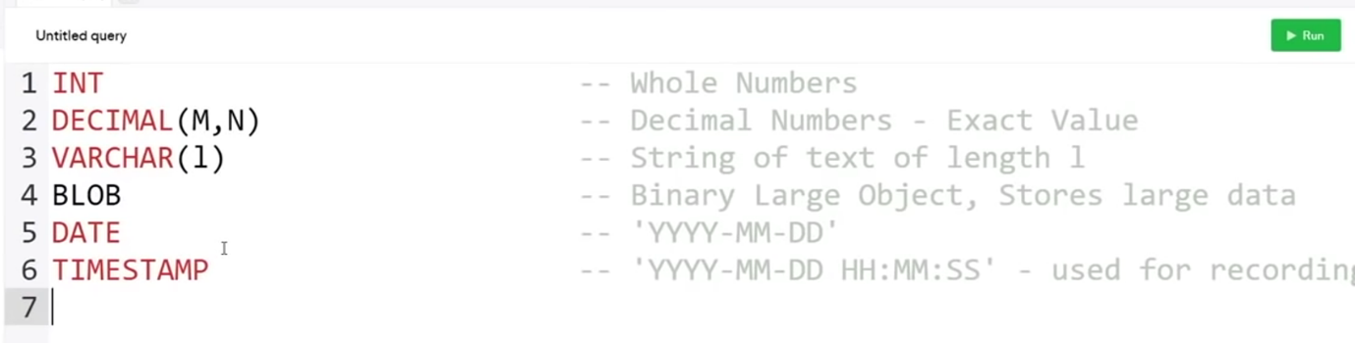

So, these are all of the basic data types that we're going to be using in SQL. Now, these aren’t all of the datatypes. There are actually tons of datatypes. And depending on the relational database management system that you're using, a lot of them have different datatypes to do different things. I would say that these six datatypes right here make up like the core SQL datatypes. Like these are probably the most common datatypes that you're going to see. But just keep in mind that there are a few others.

Now, we're using the MySQL database. And all of these datatypes are going to be able to be used in the MySQL database management system. And all of these are going to be used, for the most part, in any relational database management system. But like I said, specific database management systems will allow you to use different datatypes depending on how they want to implement things. So, let’s go through these different datatypes and I’ll kind of walk you guys through how to use them. So, INT. This is actually going to refer to an integer. So, anytime you see INT just like that, I-N-T, that basically means any whole number, right? So, this is any sort of whole number. But it can’t have decimal places after it. If you want to be able to store decimals, you can use this decimal datatype. And the decimal datatype will allow you to store decimals. And you'll see, we have this parenthesis here after decimal. And I have M and N in here. Now these are actually both going to end up being numbers. So, M is going to be the total number of digits that you want to store for this number. And N is going to be the number of digits that you want to store after the decimal point. So, when we're working with databases you have to be very specific about the different information.

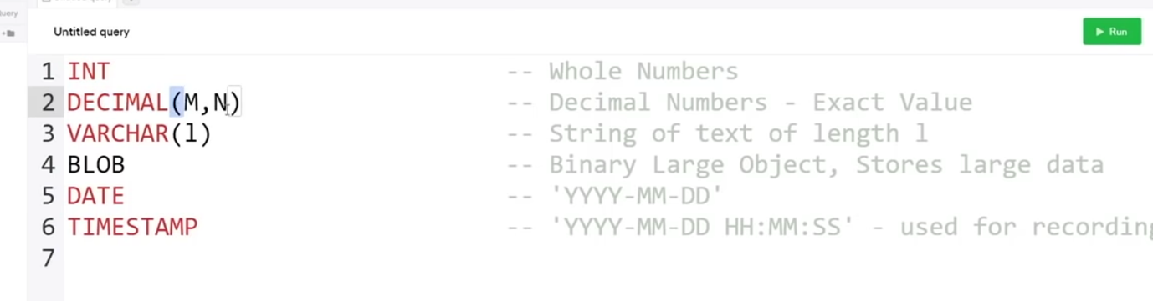

1:18:50

And specifically, the number of digits that you want to store for a number. So, what we could do is I could say like 10 here and I could put a 4 over here.

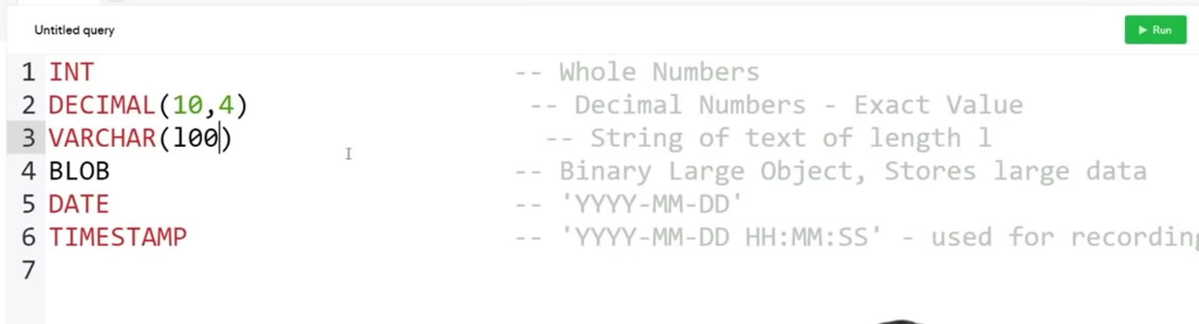

And what this means is we want to store a decimal number with 10 total digits and 4 of those digits coming after the decimal place. So, you can specify, you know, depending on how accurate you want these numbers to be stored, you can modify those numbers.

Down here we have VARCHAR. And this actually stands for Variable Char or Variable Character. This is basically a way that we can store a string of text. So, VARCHAR, we have these parentheses after here. And you can put a number in here. So, if I put a 1 in here, then this is going to store a string of text, length 1. If I put (100) in here, this is going to store a string of text with 100 characters. So, that means that the maximum number of characters that you can store inside of a VARCHAR(100) would be 100.

Down here we have BLOB which stands for Binary Large Object. And this is basically just a structure that can store large amounts of binary data. So, if you have – a lot of people will use these for like images or files. Like you can store those inside of a BLOB. And they'll be able to be stored in the database. We also have DATE. So, DATE will be like a specific date and time.



And you can see we format a date like YYYY-MM-DD. So, this would be the year, the 2-digit month, and then the 2-digit day. You can also have a TIMESTAMP, which is similar to date, but it’s generally used for recording like when things happen. So, you can record like when an item got inserted into the database or something like that. So, over here it’s just YYYY-MM-DD and then we have the hours, minutes, and the seconds. So, those are all, like I said, the main datatypes that you're going to be using. But these aren’t all the datatypes. So, depending on the database management system that you're using, you want to check to see what specific datatypes they offer. But like I said, for the most part, these should work in just about any system.

So, now I want to talk to you guys about creating database tables. So, what we can actually do is we can create tables and we're going to have use those datatypes to tell the relational database management system what types of data we want to store in each column in the table. So, in order to create a table, we're actually going to type out some SQL. Now, I’m just going to type out CREATE TABLE. And these are two SQL reserve words. CREATE and TABLE. And you'll notice that I typed them in all capital letters. Now, this is actually a pretty common convention when writing SQL queries. A lot of people will write these reserve words in SQL in all capitals.

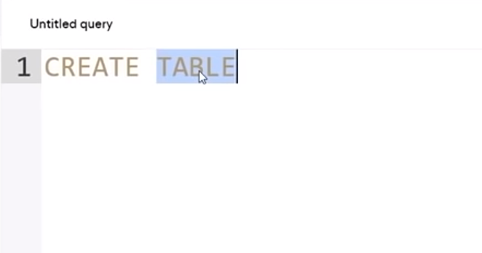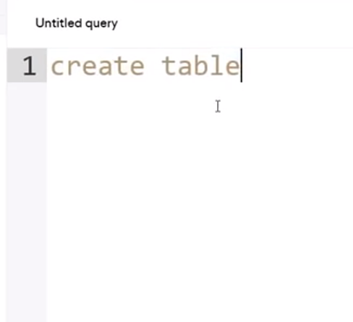

But you don’t have to. If I wanted, I could write create table just like that. And you’ll see it’s getting highlighted the same way. The reason that people write these in all caps is because then it’s easy to distinguish the SQL from any other text that we might be writing. So, I would say for the most part, just stick with making these all uppercase and you should be fine. So, I’m going to say CREATE TABLE. And then I want to type in the name of the table that I want to create. So, what we're going to do is we're going to actually create a database table. 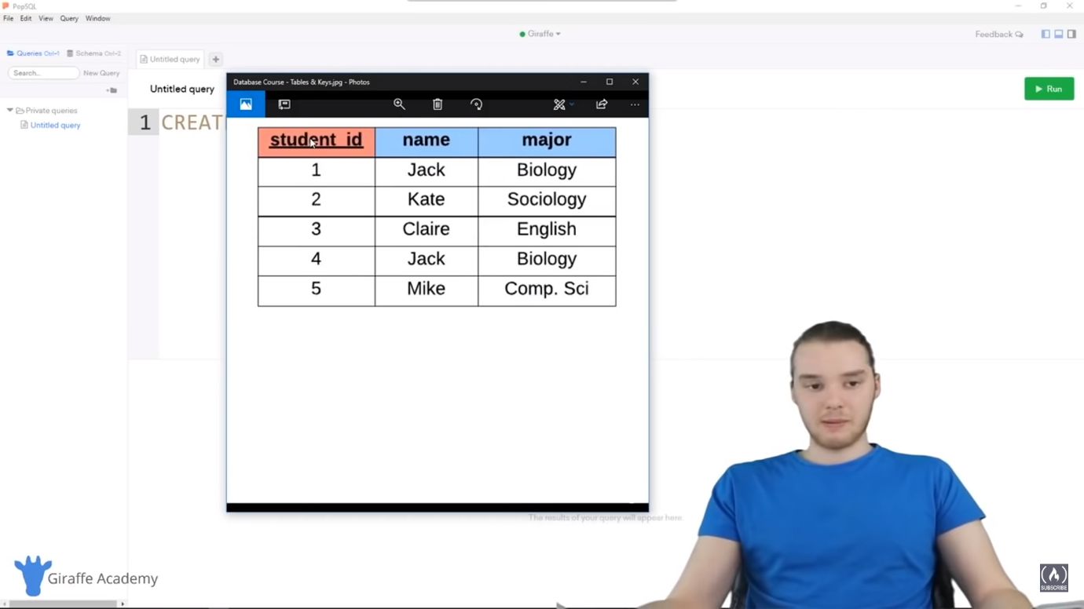

So, I actually have a database table set up over here. You'll see it’s a student table. And it’s storing just a list of students for like maybe in a college or university. So, there’s three things that we're storing about this student. The student’s ID, the student’s name, and the student’s major. So, we're storing all of this information about this student. So, what I can do now is I can actually create this exact table inside of my database. So, I can say CREATE TABLE. We'll call it student. And you'll notice that I made this lowercase. So, this isn’t an SQL reserve word, so I’m not going to make it uppercase. And then what I can do is I can just make an open and closes parenthesis and a semicolon. Now, any command that you write in SQL is always going to end with a semicolon. And if you're just starting out, you might forget to put that semicolon in there, but you want to make sure that you always put it in there otherwise it’s not valid SQL. So, I’m just going to click Enter. And I’m going to write down here in-between these parentheses. 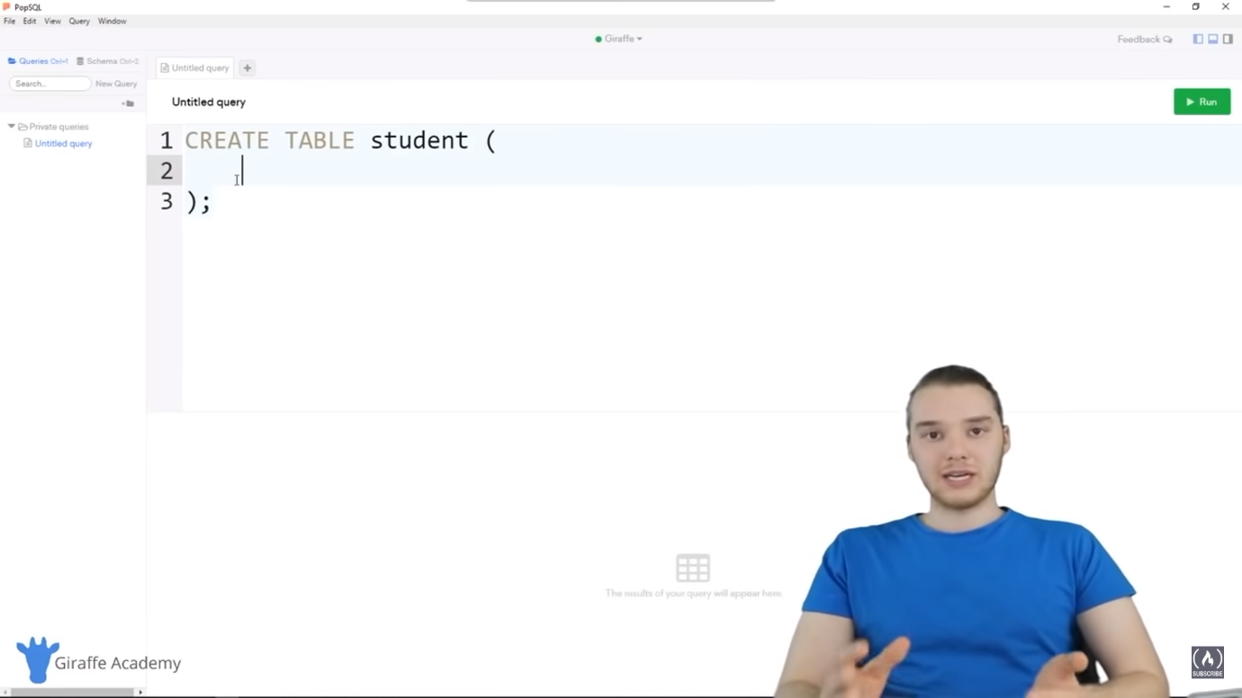

And what I’m going to do is I’m going to start defining the different columns or the different attributes on this table. So, what we can do is we can define a column name and then a column datatype. So, I can come over here and I can say the first attribute. So, in my case, the first attribute for this table is going to be student ID. And you'll also notice that student ID is a primary key.

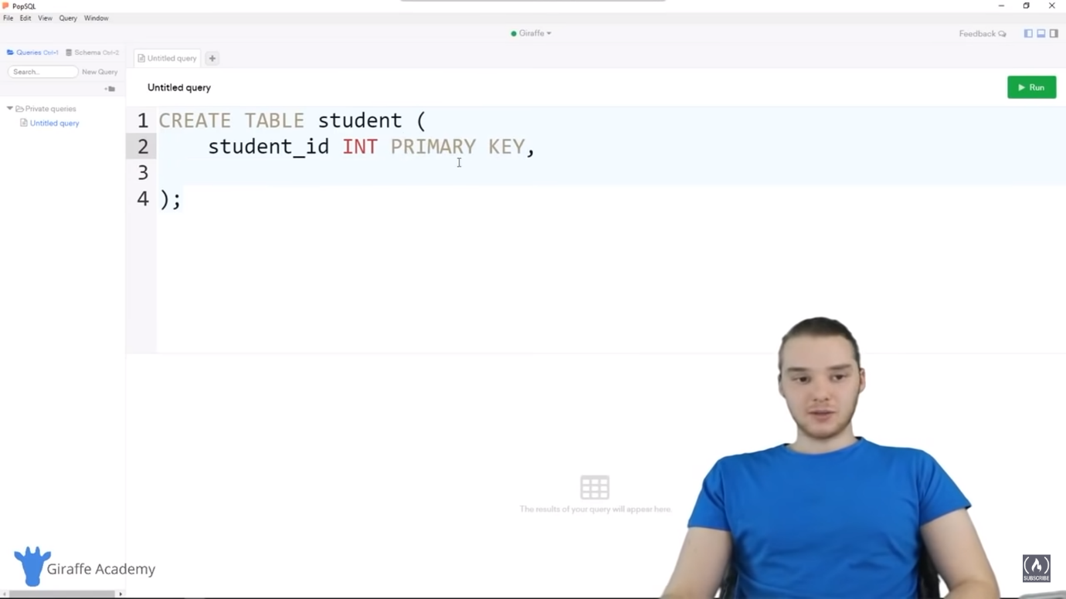

So, on this table, student ID is the primary key. Meaning it’s the column on the table which will uniquely identify the specific row. So, I'm just going to call this student_id. And now I need to give this a datatype. So, I’m going to give this a datatype of INT because all of these ID’s as you can see, are integers, right? They’re just integer numbers. Now because this is going to be the primary key for this table, I need to denote that. So, over here I can just say PRIMARY KEY, just like that. And what that’s going to do is it’s going to tell MySQL that this is going to be the primary key for the table.

The next thing we want to store is the student’s name. So, I’m just going to say name. And the name is actually going to be a string. So, this could be like Jack or Tommy or Kara, right? It’s a name that we're storing about this table. So, over here I’m going to make this a VARCHAR. And then I’m going to make an open and closed parenthesis.

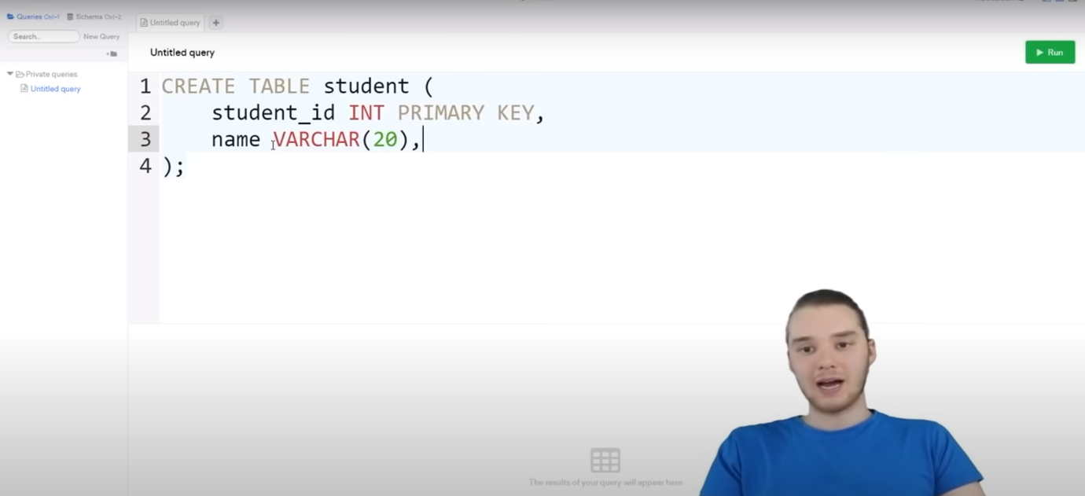

Now, remember, with the VARCHAR datatype we have to tell MySQL how many characters we want this to be able to store. So, with someone’s name, what you want to do is you basically just want to think like how many characters do we really want to allocate to storing someone’s name? Because here’s the thing, if I allocated like 1000 characters for someone’s name, Will in reality, normal people don’t have a name with 1000 characters, right? I mean maybe your name would be 20 characters or 30 if you're really pushing it, but 1000 is just totally out of the bounds of reality. And you have to think if you're storing like millions of names, potentially, you know, allocating 1000 characters to each name when you only need 20 is going to take up a lot of extra space in your database. So, I think what we should do is maybe say like 20. So, let’s say that the maximum length of someone’s name we want to store is going to be 20 characters. And really, you know, depending on the domain of the application that you're building, that’s going to be different. But in my case, let’s just say it’s 20. And then finally we wanted to store the student’s major.

So, I can say over here, major. And this is also going to be a VARCHAR. So, why don’t we also allocate 20 characters to their major. And that should be enough. So, you'll notice that I’m defining each of the attributes, each of the columns on the table. And then I’m putting a comma. And then I’m defining the next column. And then I’m putting a comma. And then the final column.

So, this right here, this CREATE TABLE statement is basically going to create this table over here for us, right?

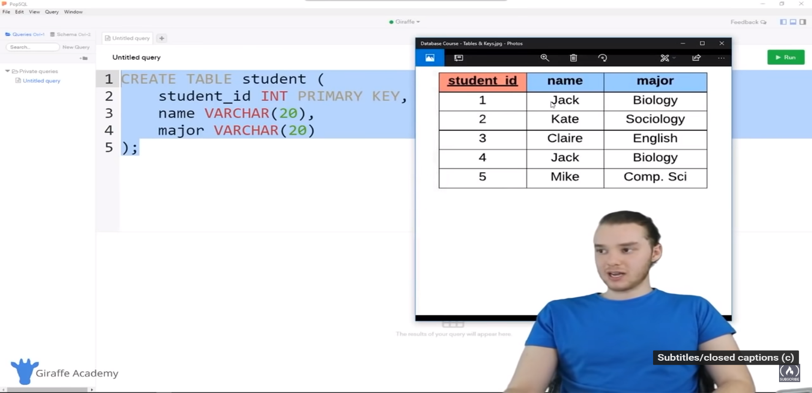

We have the primary key, which is an INT. And we have a name and a major which are strings. So, that’s going to go ahead and do that for us. Now, from inside PopSQL, what’s really cool is we can just click on this query right here. Click on this SQL statement. And I can come over here and click Run. And what this will do is it’ll automatically run this SQL on our MySQL server. So, I'm going to click Run. And you'll see over here we get a success message that says Rows affected: 0.

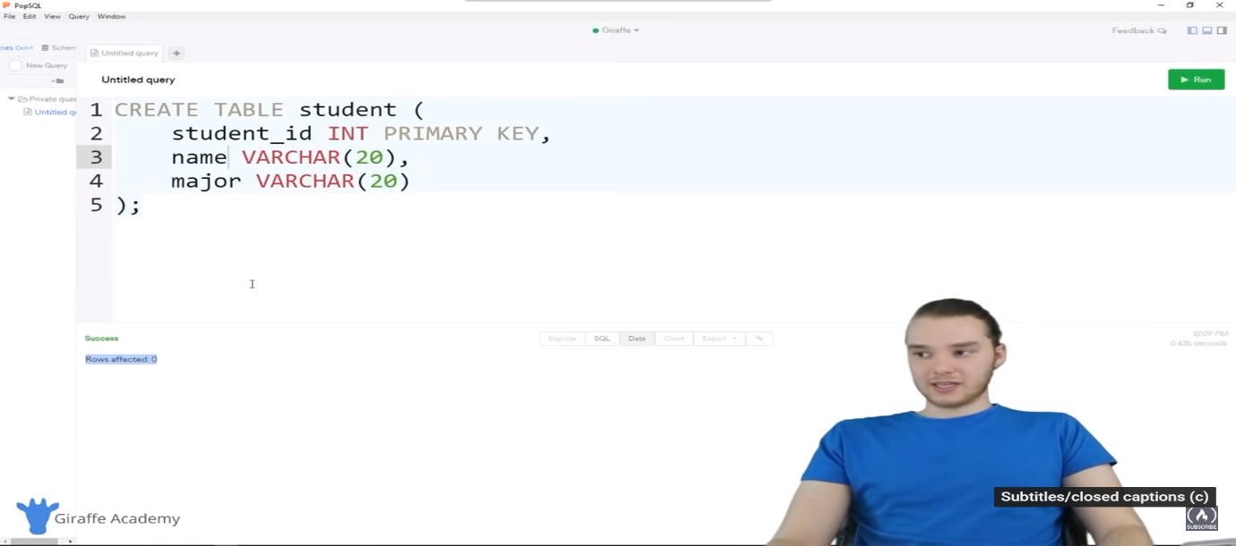

So, that actually was able to create that new table in our database. So, that is basically how we could create a table. And now we have this table stored in our database. I want to show you guys another thing we can do. So, over here I’m defining the primary key. So, student_id was the primary key, right? It’s the one column that’s going to uniquely identify each row. And if you want, you can put primary key over here after like student_id. 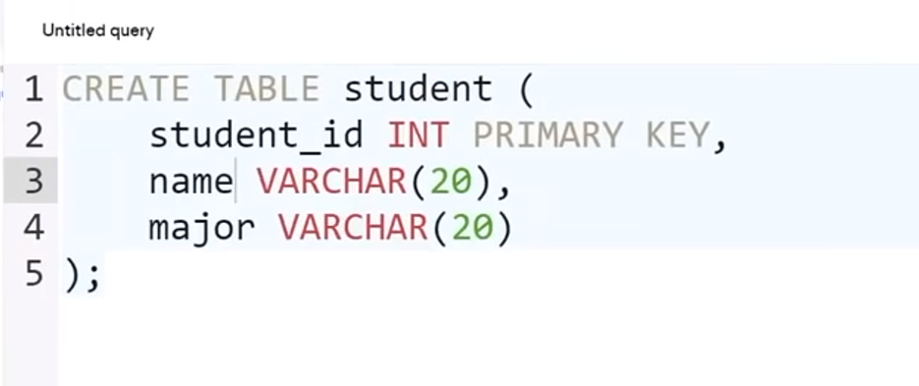Or what you can do is you can get rid of this and you can define this down below. So, instead of defining the primary key up here next to student_id, I can come down here and I could change it. So, I could say now PRIMARY KEY, and then I can make an open and closed parenthesis. And in here, I could put the name of the column that I want to be the primary key. So, in my case, I’ll just say student_id.

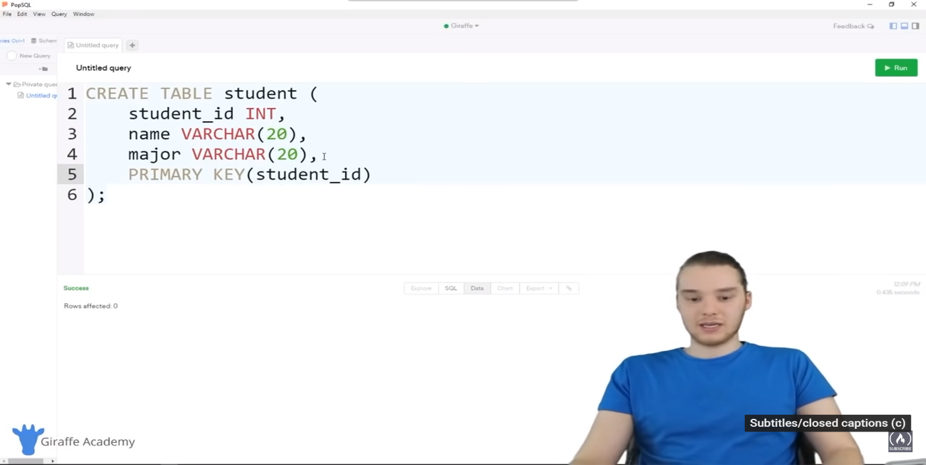

So, now what this is system is that the primary key is going to be student_id. So, this is an equivalent to what I was doing up here. It’s just another way that you can do it. And so, now we already have our table created, so I’m not going to go ahead and create it again. All right, so now that we have our student table created, let’s go ahead and make sure they created correctly. So, what I’m going to do is I’m going to come down here and I’m going to type out another MySQL command. So, I’m just going to type out DESCRIBE. And then I’m going to type in the name of the table.

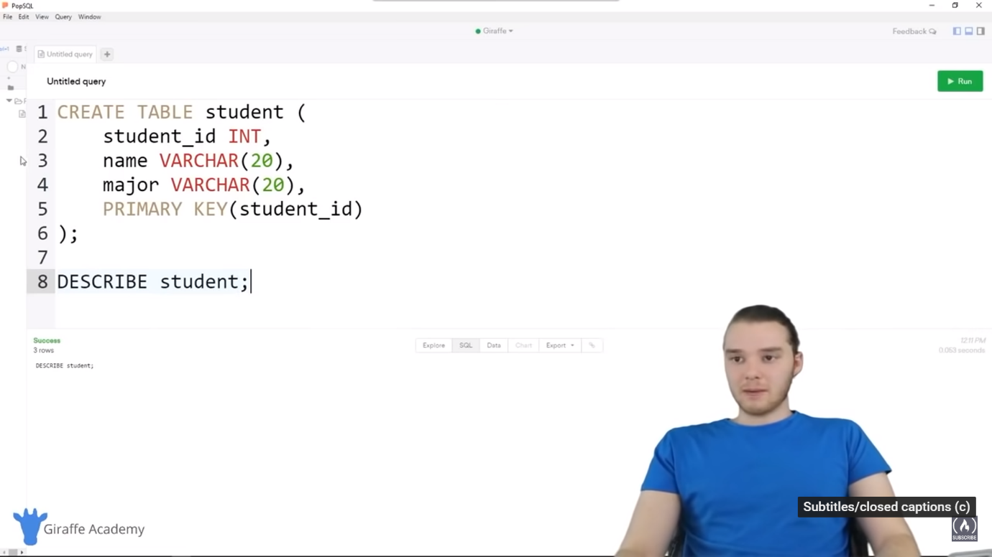

So, in our case it’s going to be student. And you'll notice with PopSQL, if I click over here on this query, it gets highlighted in that blue colour. And if I click down here on this query, it gets highlighted. So, what you can do with PopSQL is you can have like a query up here. And you can run that query or you can click on this query down here and run it. So, I’m going to click on DESCRIBE student. And then I’m going click Run. So, you'll see that it’s actually describing the table that we just created. So, there’s a list of all these different fields. We have student_id, name, and major. It’s telling us the datatypes that we're storing. So, like varchar(20). And then it’s telling us a bunch of other information which we're going to get into later. So, what this is, it basically described everything about this table.

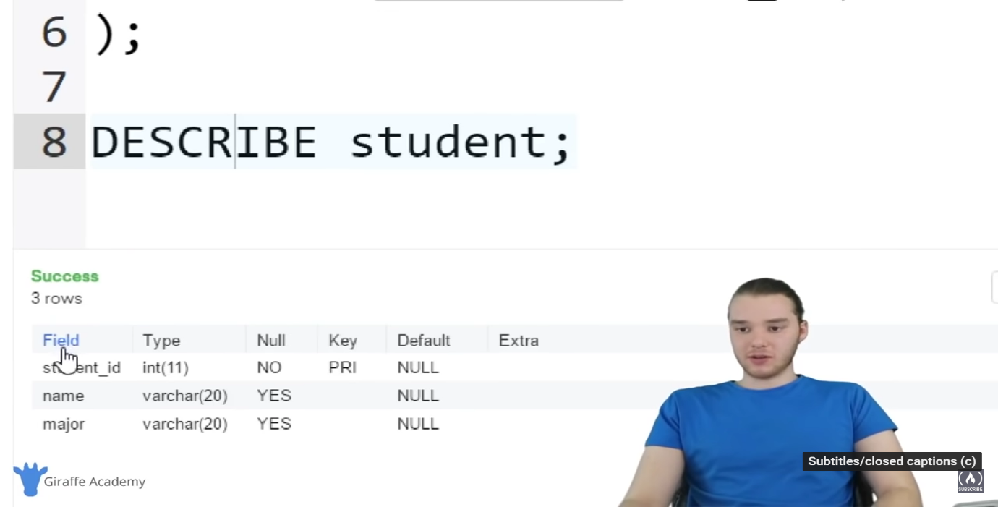

So, now what I want to show you guys how to do is delete and modify a table. So, now that we've created a table and we saw that it got created correctly, if you wanted, you could delete the table. So, what I could do is I can come down here and type out DROP TABLE and I can just type the name of the table. So, in our case, it’s the student table, and a semicolon. And now I’m going to click on here and I’ll click run.

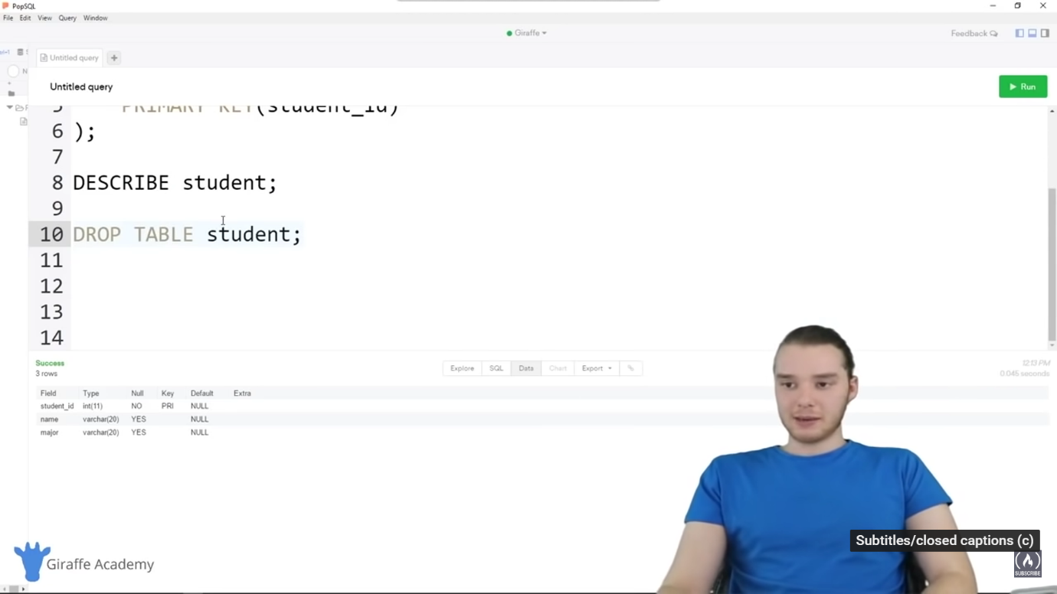

And what this is going to do is it’s going to drop that table. So, now if I came up here and I click on describe student, in other words, I’m saying I want to execute this command. And I click run, you'll see that it says “NO_SUCH_TABLE”.

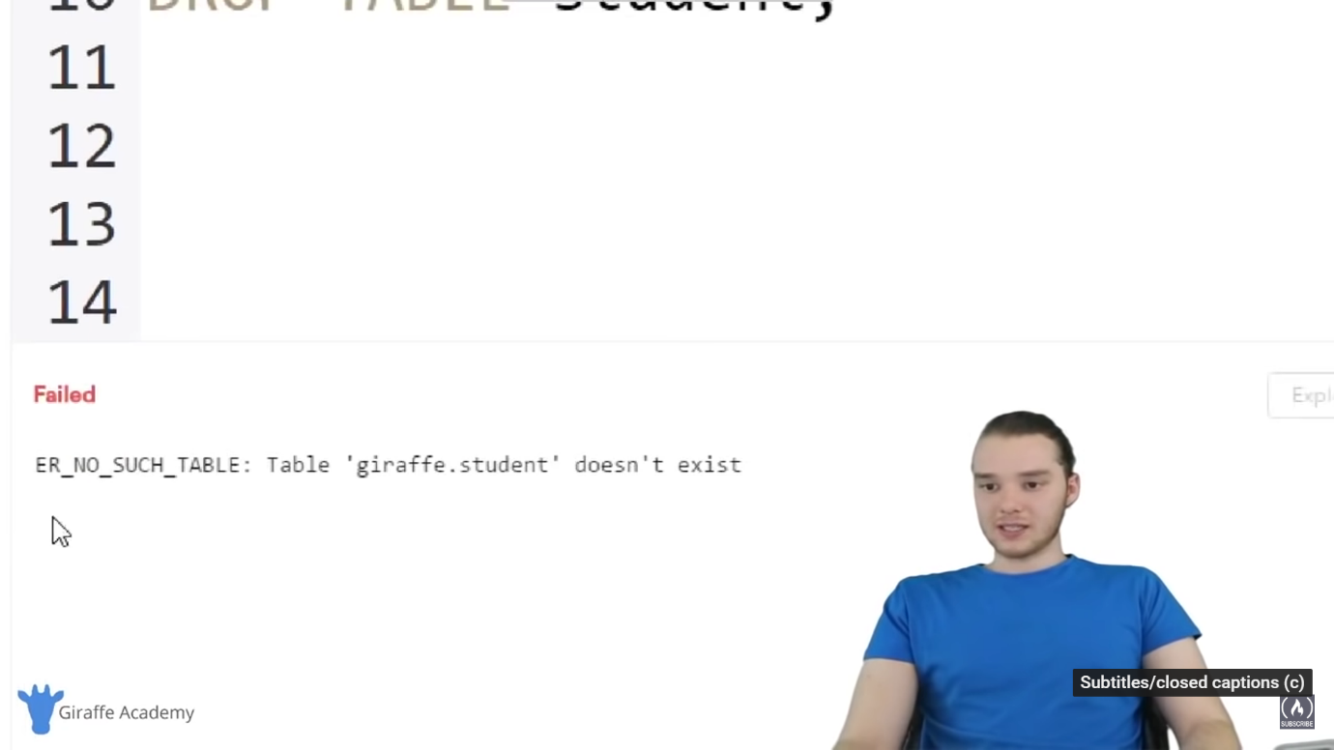

Table ‘giraffe.student’ doesn’t exist because remember, we just dropped it. So, what we can do, is we can actually create again. So, I’m going to click on this CREATE TABLE query and I’ll click Run. And that will go ahead and create it. So, now if we click DESCRIBE student, you’ll see we get the table back because we created it again. So, you can drop the table. You can also modify the table. So, let’s say that after the table was created, you wanted to give it another column. What I could do is I could add another column. So, I could say ALTER TABLE. And then say student, because that’s the name of the table. And then I could say ADD. So, what this is going to do is it’s going to add an extra column onto the table. So, why don’t we add a column for GPA. So, we could store a student’s GPA and that’s going to be a decimal. So, I’m just going to click a semicolon. And this is going to go ahead and end off this command. Now, with decimal, remember I showed you that you could put numbers after here, like 1 and 2. So, what we're going to do is generally a GPA would be like 3. Then something, something..Or 4. something something. So, we're going to have this be three total digits with two of the digits occurring after the decimal point. So, now I can go ahead and run this command and you'll see it says success down here. So, if we were to describe the student table again,

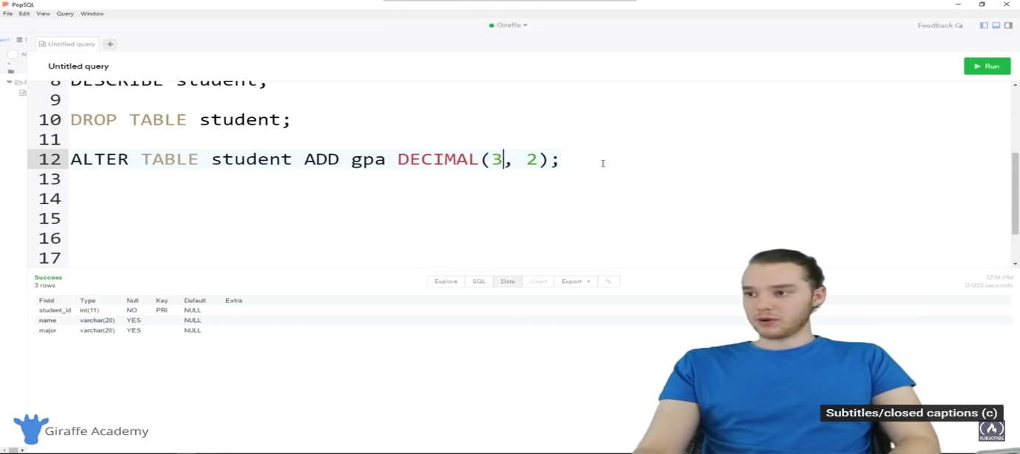

if I just click on this and click Run, now you'll see we have that extra column in here, GPA. And it’s a decimal (3,2). So, that is how we can drop a table and that’s also how we can alter a specific column. If you wanted, you could also drop a specific column. So, I could say ALTER TABLE student. And over here, I can just say DROP COLUMN and just type in the name of the column. So, what this will do is it’ll drop that GPA column from the table. So, let’s go ahead and run. We get this success message.

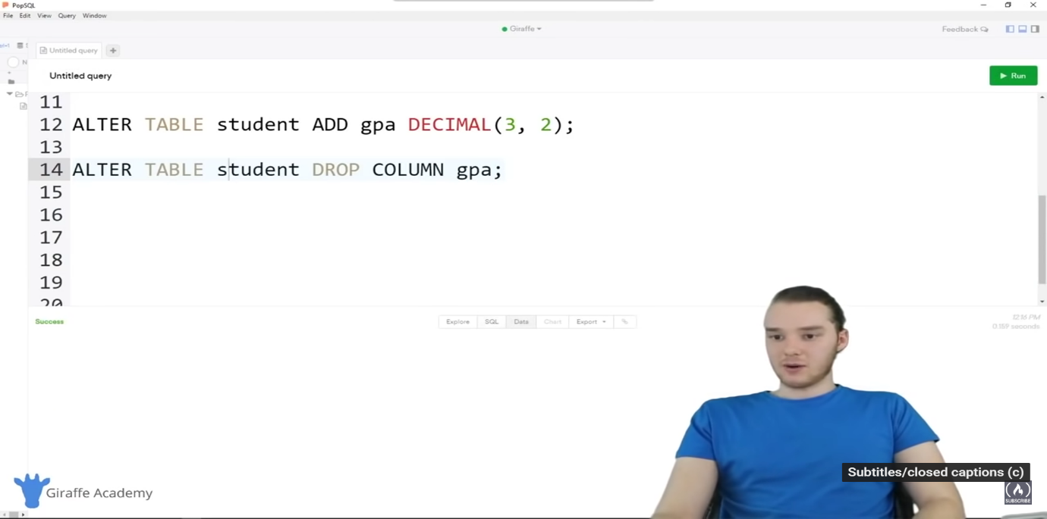

Now, if I describe the table and I clicked run, you'll see that the GPA field went away. So, I actually dropped that field. So, you can create tables. We can add columns onto tables. We can remove columns from tables. And then we can just remove the table altogether. So, hopefully that show you guys some of the basics of doing those operations on tables. Now, obviously whenever you're creating your database, the first thing that you want to do is define your database schema. In other words, you want to create all the different tables and then you can start inserting data into the tables as such.

So, in the next tutorial I'm going to talk to you guys about inserting data into tables, so we'll actually insert some student information into our student table.

-----------In youtube 1:31:06 and in notepad also 1:31:04-----------------